St. John’s UCC Annual
__________________________________________________________________________________________
Rummage &
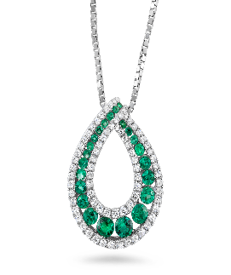
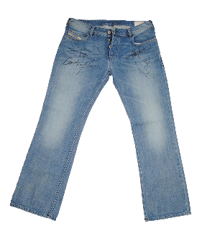
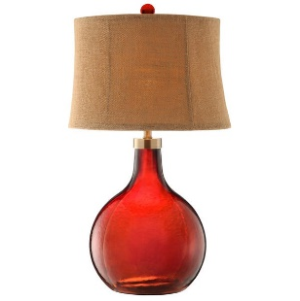
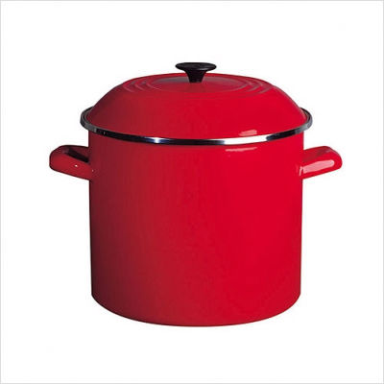
Bake Sale
This Photo by Unknown Author is licensed under CC BY-NC
This Photo by Unknown Author is licensed under CC BY
Friday, May 19
9 am-5 pm
Saturday, May 20
9 am-3 pm

527 N. William St., Marine City
Multi-family, household, furnishings, clothing, more
Inside/outside- rain or shine!

“Name Your Own Price” pricing
All proceeds benefit St. John’s United Church of Christ
____________________________________________________________

