St. Johns United Church of Christ
527 N. William Street, Marine City, MI 48039

Contents
News from Pastor Ken 1
Pastor Ken News Cont. 2
Birthdays 3
Anniversaries 3
Worship Ministry 3
Military Prayer List 3
Prayers Needed 3
Kid’s Page 4
Fourth of July Tribute 5
Scripture Readings 6
Reports 7-9
Council President 10
Additional Activities 11

News from Pastor Ken

Greetings to all.
Now that seem to be making our way through what has been another interesting year. I am glad to see that family and friends are starting to gather and share time together. This time of isolation has been difficult for many. I hope you are enjoying the summer.

As I look around, I am delighted to see the gardens have exploded with all kinds of wonderful color and fragrances. I am excited about the new activity and helping hands taking part in shaping my gardens. I am thrilled that summer is here and the long winter is behind us. It is a glorious summer.

Personally, July is for me a rich time of reflection and gratitude reflecting on times of major transformation in my life. As we start the back half of the year, I am reminded to embrace each new day with all the opportunities, challenges, and times of profound spiritual enlightenment that every new day can bring. As one journey ends a new and exciting one begins.

I am hoping that for you this summer is a time of reflecting and relaxing. For some of you it will be a time of graduations, weddings, vacations, get-a-ways, and trips to the beach. I offer traveling mercies to you all, wherever this summer’s adventures take you.

Remember to stop into a local church and say hello and share with them about your home church and how God has touched your life. One of my fond memories as kids was my mother always had us stop by churches wherever and whenever we were visiting places to go in just say a little prayer and look around. She would say that it was important so when the day came to meet God face to face, he would recognize us and remember we had stopped by to say hello.
https://www.facebook.com/Stjohnsuccmarinecity/

The purpose of a newsletter is to provide specialized information to a targeted audience. A school newsletter can be a great way to develop a strong relationship with parents.
First choose a short title for your newsletter— something like "School News," or “Back to School.” As you choose the title, also take time to think about the newsletter’s theme. What important messages do you want to send parents and families?
Next, establish how much time and money you can spend on your newsletter. These factors will help determine how frequently you publish the newsletter and its length.
Use the body of your school newsletter to keep parents apprised of major assignments and class events, as well as any of school district news. Also share news for specific grade levels, and tell parents about upcoming events, new faculty, and school policies.

Dear Parents

That funny little story still has me stopping by churches whenever I am on the road whether traveling for pleasure or for work.

For some of us this has been a difficult and challenging summer dealing with issues of health, money, loss or just life on life’s terms. Perhaps even to the point of trying our faith. Please know that you are not on this journey alone. God is always with us and makes God’s presence known by surrounding us with friends, family (and as I like to say, some I am related to) and the occasional encounter with a stranger that God sends along to deliver a message. I genuinely believe that God is with me the most when times are hardest and I feel it the least. My history is proof. I believe it to be true for you as well.

Others of us are just laying low enjoying those laid-back days of summer. Remember that list of everything we were going to do this summer…relax a little. The list is always bigger than the time and energy to do it. Do what you can but remember to enjoy.

As we spend the summer relaxing and having fun, we have so much to look forward to with a new season of worship and spiritual growth. May your summer be a restful, revitalizing time, Spirit-filled and surrounded by the grace and love of God. And remember that regardless of where the summer takes you, you are held in God’s unconditional love, boundless mercy, and unending grace and there is a place for you here. Have a great summer. See you Sunday!

Take care and be well, Peace
Ken

**Live streaming of Sunday Services will continue at 9:00am on the St. James Facebook page and St. Johns Sunday Services will continue at 11:00am on the St. Johns Facebook page. Both will be available as a video any time after the live streams.**

**Live streaming of Sunday Services will continue at 9:00am on the St. James Facebook page.**
Live streaming of Sunday Services will continue at 11am. from St. John’s Facebook page.

Pastor Ken Newsletter Continued
Page 2 of 11
Page 3 of 11

Happy Birthdays in

July and August
Happy Anniversaries in
July and August
7/1 Thomas Fisher
7/1 Karen Jolicoeur
7/1 Brenda Fisher
7/5 Aaron Forest
7/7 Marilee Schultz
7/7 Katie Phelan
7/9 Tom Faucher
7/18 Bea Gubanche
7/18 Lori LaMontagne
8/13 Janet Bulgrien
8/24 Don Weichert

7/8 Dorothy & Kurt Schultz
7/26 Georgia & Phelan
7/27 Christina & Bill Galvin
7/27 Mary & Bill Galvin
7/30 Denise & Douglas Andrews
8/8 Lisa & Aaron Forest
8/11 Megan & Mark Hincherick
8/25 Lois & Don Weichert

Prayers For ……

Prayers for …. Claudette, Linda, Wayne B., Shirley, Carole, Deborah, Karen, Keith, Terry, Janette, Barb, David, Lynn, Nikki, Ralph, Sue, Frazer, Lee, Arnie, Tom, Jennifer, Dennis, Carol, Joy, Jack, Harvey, Lynn, Jim, Karen, Jim M, Don, Lois, Trisha, Tom, Brenda, Bernetta, Joe, Bill, George, Irene, Nelson, Mary F., Nancy H., Ben H., Michelene, Don A, Prange Family, Mary F., Tamara, Families of St. John & St. James

Worship Ministry

Military Prayer List
I will be including a list in the newsletter of our men and women in the military, to acknowledge those who serve and to pray for their safety. Please submit your love one’s, family member or friend’s name, rank, and branch of service to be placed
on the list.

Josh Bieske Staff Sgt. US Air Force
Alex Tite Private US Army
Joshua Bieske Sgt. First Class US Air Force

Volunteers Needed
Please sign-up
Please consider signing up for the ministries of Usher/Greeter, Liturgists, Communion Servers, and Altar Care.

Page 4 of 11

Kid’s Page

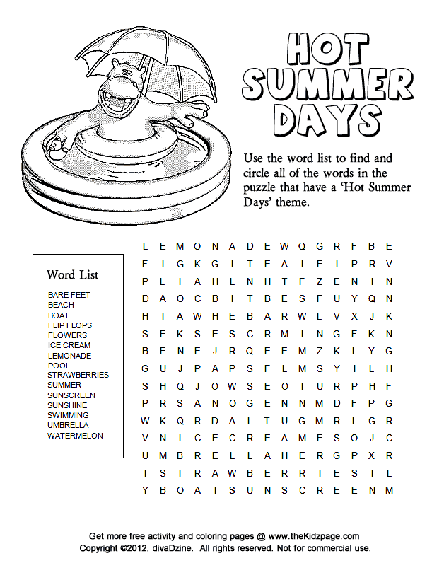

Page 5 of 11

Fourth of July Tribute!

Page 6 of 11

Scripture Reading for July

Sunday, July 4 Sunday, July 11
Sixth Sunday after Pentecost Seventh Sunday after Pentecost
2 Sam 5: 1-5, 9-10 2 Sam 6;1-5, 12b-19
Ps 48 Ps 24
Ezek 2: 1-5 and Ps 123 Amos 7: 7-15 and PS 85: 8-13
2 Cor 12: 2-10 Eph 1: 3-14
Mk 6: 1-13 MK 6: 14-29
Sent with Power God-Inspired Joy

Sunday, July 18 Sunday, July 25
Eighth Sunday after Pentecost Ninth Sunday after Pentecost
2 Sam 7: 1-14a 2 Sam 11; 1-15
Ps 89:20-37 Ps 14
Jer 23: 1-6 and Ps 23 2 Kings 4: 42-44 and Ps 145: 10-18
Eph 2: 11=22 Eph 3: 14-21
MK 6: 30-34, 53-56 Jn 6: 1-21
Wherever You Are God’s Abundant Presence
Scripture Readings for August

Sunday, August 1 Sunday, August 8
Tenth Sunday after Pentecost Eleventh Sunday after Pentecost
2 Sam 11: 26-12: 13a 2 Sam 18: 5-9, 15, 31-33 Ps 51: 1-12 Ps 130
Ex. 16; 2-4, 9-15 and Ps 78: 23-29 1 Kings 19: 4-8 and Ps 34: 1-8
Eph 4: 1-16 Eph 4: 25-5:2
Jn 6: 24-35 Jn 6: 35, 41-51
Bread of Life Shaping Community

Sunday, August 15 Sunday, August 22
Twelfth Sunday after Pentecost Thirteenth Sunday after Pentecost
1 Kings 2: 10-12, 3; 3-14 1 Kings 8: (1,6, 10-11) 22-30, 41-34
Ps 111 Ps 84
Prov 9: 1-6 and Ps 34: 9-14 Josh 24: 1-2a, 14-18, and Ps 34: 15-22
Eph 5: 15-20 Eph 6: 10-20
Jn 6: 51-58 John 6: 56-69
Wisdom Quest At Home with God

Sunday, August 29
Fourteenth Sunday after Pentecost Song of Sol 2: 8-13
Ps 45: 1-2, 6-9
Deut 4: 2, 6-9 and Ps 15
James 1: 17-27
Mk 7: 1-8, 14-15, 21-23
Be Love
Page 7 of 11

Meeting Minutes / Reports

St. Johns United Church of Christ
Council Meeting MINUTES
May 10, 2021

Council Members: Georgia Phelan, Carolyn Hosford, Don Weichert, Shari Faucher, Katie Phelan, Miriam Guyor, Pastor Rev. Ken Gadd

- Call to order: 6:33 p.m.

- Opening Prayer: Pastor Ken

- Roll Call: Present: Georgia, Carolyn, Don, Shari, Miriam, Pastor Ken Absent: Katie

- Approval of Agenda: Motion to approve agenda by Miriam. Second by Shari. Carried.

- Minutes of last meeting: Motion by Shari to approve April minutes with March meeting date corrected to March 8. Second by Carolyn. Carried.

- Standing Reports

  - Treasurer’s Report: Motion by Carolyn to approve April report. Second by Shari. Carried.

  - Prayer Group- no report until Health & Vitality meetings resume.

  - Sunday School- no report until Health & Vitality meetings resume.

  - Pastor’s Report

    - Health and Vitality Team – Team initiatives to date was sent to team members. These were reviewed by council. Team will work to implement these initiatives.
    - Pastor Ken has updated our required Annual Report for the State of Michigan.
    - He has been very busy with pastoral duties: funerals, people in crisis, interest in our church.

  - Building and Grounds
    - Oven repair. Carolyn
New thermostats are installed. One works great, the other doesn’t allow full heating. The contractor will send someone to check it.

- Unfinished Business
  - Annual Meeting: TBD
  - To-do list: TBD
Page 8 of 11

  - Draft use agreement (Ken): TBD

  - Record/History book
Pastor Ken will get info to Shari for funerals and new members to enter into record book. Also it was decided to create a filing system in the church office and move existing records from Gadd Business office to St. John’s office. Shari and Miriam will work on this.
  - Rummage and Bake Sale: Thursday is set up day. Schedule for needed workers is out and baked goods are needed.
  - Scholarship recipients- Mary Martha Guild: Lorenzo Franco; St. John’s: Ian Blackstock.
The presentation service will be June 6 or 13. Georgia will give dates to high school counselor to coordinate when both can attend.

- New Business
  - Marine City business renewal has been sent in. No charge to us.
  - Annual outdoor Service and picnic will be August 15, with August 22 as rain date.
  - Emergency shut off notices will be posted in various location in the building.

- Motion made by Carolyn to adjourn at 7:50 p.m. Second by Shari. Carried.

Closing prayer: Carolyn

Next meeting: June 14, 6:30 p.m.

Page 9 of 11

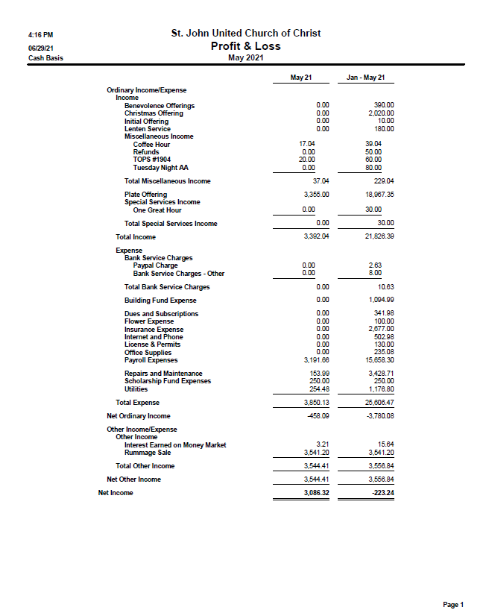

Page 10 of 11

Message from St. Johns Council President

From the Prez
July 2021

Wait a minute- July? As in almost halfway through summer? Time for me to quit planting things and start smelling the roses!
There are some roses here at St. John’s I’ve truly missed in the last year, but they’re slowly coming back. Each week we see a familiar face return to the pews. Our church groups (Ministries) are stirring back to life as well. At our June Council meeting, we discussed Prayer Group, Sunday School, and potluck dinners. And plans are forming for some of our usual events. Ah- I sense the wonderful roses of St. John’s!
Are you one of our roses? You CAN be- participation is always available to you. St. John’s could use more liturgists, ushers, and greeters, as well as other help with worship like Altar and Communion preparation. None of these are complicated or big commitments, but they have big impact for our church AND on you. We rely constantly on the same few people to continue the life of St. John’s and it would be nice to welcome more into these ministries and give the “regulars” a break!. It’s so rewarding to participate- please consider “blooming” here! There are sign-up sheets, of course, and you can always speak to me, Pastor Ken, or a Council member if you have questions.
At our June Council meeting, it was decided that trying to make an Annual Meeting happen yet this year was not really feasible. So, in lieu of this meeting, we will be issuing an Annual Report to members. Each ministry/group will have their report for 2020 included. If you were involved with one of our groups last year and haven’t heard from me yet, you will, as I’ll be looking for your report which normally would have been presented at the Annual Meeting in January. These reports will be due to me by mid-July. If anyone has any questions about their report or the Annual Report, just let me know.
As you’ve probably noticed, we are starting to refer to our groups here as our Ministries. We have a new agenda we use for Council meetings to reflect this, too. This is all part of what we started with the Health and Vitality meetings before Covid arrived. We are picking this back up and intend to continue with our ongoing development as a congregation in service to Christ. This is an extremely rewarding Ministry to participate in and we welcome you to contribute. Just let me know if you’re interested and I’ll make sure you’re “in the loop” for what’s happening here at St. John’s!
Georgia

Page 11 of 11

July Activities
Sunday, July – Sunday Worship with Holy Communion- 11am

Sunday, July – Sunday Worship with Holy Communion – 11am

August Activities
Sunday August 1 – Sunday Worship with Holy Communion – 11am

Monday, August 9 - Church Council meeting 6:30 p.m.

Sunday, August 15 – Sunday Worship Outside with Holy Communion – 11am – Rain Date August 22nd at 11am. Church picnic following service.

Sunday, August 29 – Sunday Worship with Healing Service - 11:00 a.m.

October Activities
Saturday, October 2 - Blessing of the Pets 10 a.m. @ St. John’s

Saturday, October 23 - Chili Potato Dinner 5:00-7:00 p.m.

Additional Activities

Sunday Services
Sunday Service is in person 11:00 a.m. Service is also available via online streaming on Sunday mornings at 11:00 a.m. If it is not available on our Facebook page, please try St. James’ - it is the exact same service. Both will be available to view as a video any time after the live streams. www.facebook.com/Stjohnsuccmarinecity or www.facebook.com/St.James-United-Church-of-Christ-10150090210425008.

Council Meetings
Church Council’s next meeting is June 14th at 6:30 p.m. in the Community Room.

Sunday School
Sunday School will resume in the fall.

Health & Vitality Meetings
We are prepping to restart this important function! Watch for details.

Coffee Donations
There is a container on the counter by the coffee pots for freewill donations to help pay for the cost of Coffee Hour. Any help will be greatly appreciated.

Annual Meeting
To be determined.

St. Johns United Church of Christ
527 N. William Street
Marine City, MI 48039
Phone: (810) 765-5371
E-mail: kgadd@stjohnsmarinecity.org

We’re on the Web!
stjohnsmarinecity.org

JULY / AUGUST
NEWSLETTER

