St. Johns United Church of Christ
527 N. William Street, Marine City, MI 48039

Contents
News from Pastor Ken 1
Pastor Ken News Cont. 2
Birthdays 3
Anniversaries 3
Worship Ministry 3
Military Prayer List 3
Prayers Needed 3
Kid’s Page 4
Father’s Day Poem 5
Scripture Readings 6
Reports 7-10
Council President 11
Additional Activities 12

News from Pastor Ken
Summertime, Summertime! People are actually starting to come out of seclusion and are talking about vacations, weddings, family reunions, and fun on the water. To say nothing about the fact that the gardens are bursting, the birds are chirping, and everyone seems just a little happier. Must be the vitamin D.

I do so enjoy finally having morning prayers and meditation outside on the deck. With a couple cups of coffee or tea, of course.

Something about summer seems to give us permission to take a deep breath, smell the roses (literally and figuratively) and give our minds, bodies and spirits a moment to simply be. Slow down, plan a day trip, go to the beach or anywhere, sit lazily under a tree and read, or simply enjoy some log awaited time with family and friends.

I have found the challenge for me, and maybe for you, is to not rush through the relaxation. Just be present and enjoy. You know that long list of things you need to get done this summer. I have learned to start the summer accepting the fact that the list of things I want to do is longer than the summer is. So, get done what you can but not at the expense of having some time for yourself.

Summer is a time of regeneration, discovery, and of transformation. The summer is full of exciting opportunities such as graduations, weddings, and road trips. It can also be a challenging time for some. Life certainly seems to be full of interesting journeys. Whatever the summer holds for us, know that we lift each other up and keep each other in our hearts and in our prayers.

It always amazes me that even as the church year winds down, some of you are already busy planning and getting ready for the fall church calendar. So many of you are busy in selfless ministry. Please remember to take time to breathe and enjoy. This includes Music, Sunday School, outings, fun activities, fellowship and outreach, meals, events, coffee hours, keeping the inside and outside of the property well cared for, bulletins and newsletters published, and on and on and on. Makes me want to rest just thinking about how hard you all work. A BIG thank you to all of you.

https://www.facebook.com/Stjohnsuccmarinecity/

The purpose of a newsletter is to provide specialized information to a targeted audience. A school newsletter can be a great way to develop a strong relationship with parents.
First choose a short title for your newsletter— something like "School News," or “Back to School.” As you choose the title, also take time to think about the newsletter’s theme. What important messages do you want to send parents and families?
Next, establish how much time and money you can spend on your newsletter. These factors will help determine how frequently you publish the newsletter and its length.
Use the body of your school newsletter to keep parents apprised of major assignments and class events, as well as any of school district news. Also share news for specific grade levels, and tell parents about upcoming events, new faculty, and school policies.

Dear Parents

It is nice to take a well-deserved break and allow things to be just a little more casual. As we venture off for a time of reflection, vacations, and summer fun, remember that wherever you are, God is there also. So, when you have an opportunity, stop in other churches along the road and say “hello”. Wherever you are, God is always happy to see you. And when you are back in town, we look forward to seeing you.

Remember that regardless of where the summer takes you, you are held in God’s unconditional love, boundless mercy, and unending grace and there is a place for you here. Have a great first month of summer. I look forward to sharing the summer with you.

Take care and be well, Peace
Ken

**Live streaming of Sunday Services will continue at 9:00am on the St. James Facebook page and St. Johns Sunday Services will continue at 11:00am on the St. Johns Facebook page. Both will be available as a video any time after the live streams.**

**Live streaming of Sunday Services will continue at 9:00am on the St. James Facebook page.**
Live streaming of Sunday Services will continue at 11am. from St. John’s Facebook page.

Pastor Ken Newsletter Continued
Page 2 of 13
Page 3 of 13

Happy Birthdays in June
Happy Anniversaries in June
6/6 Lynn Reh
6/8 Bill Galvin
6/17 Bob Fritz
6/6 Lynn & Rev Harvey Reh
6/22 Katie & Patrick Phelan
6/30 Denise & Douglas Beattie

Prayers For ……

Prayers for …. Claudette, Linda, Wayne B., Shirley, Carole, Deborah, Karen, Keith, Terry, Janette, Barb, David, Lynn, Nikki, Ralph, Sue, Katie, Frazer, Lee, Arnie, Tom, Jennifer, Dennis, Joy, Harvey, Lynn, Sally, Shirley, Jim M, Marian M., Debbie V., Don, Lois, Trisha, Tom, Brenda, Bernetta, Joe, Prange Family, Linda, Ron, Jack L., John G., Ben H., Michelene, Phillis, Families of St. John & St. James

Military Prayer List
I will be including a list in the newsletter of our men and women in the military, to acknowledge those who serve and to pray for their safety. Please submit your love one’s, family member or friend’s name, rank, and branch of service to be placed
on the list.

Josh Bieske Staff Sgt. US Air Force
Alex Tite Private US Army
Joshua Bieske Sgt. First Class US Air Force

Worship Ministry

Volunteers Needed
Please sign-up
Please consider signing up for the ministries of Usher/Greeter, Liturgists, Communion Servers, and Altar Care.

Page 4 of 13

Kid’s Page

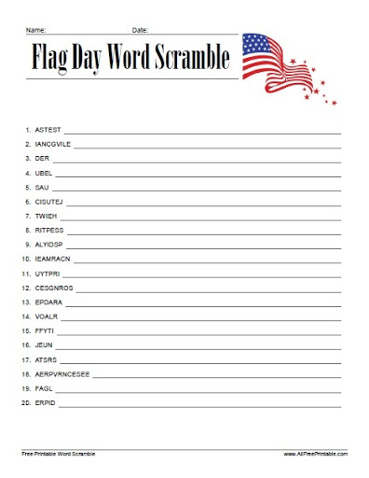

Page 5 of 13

Father’s Day!

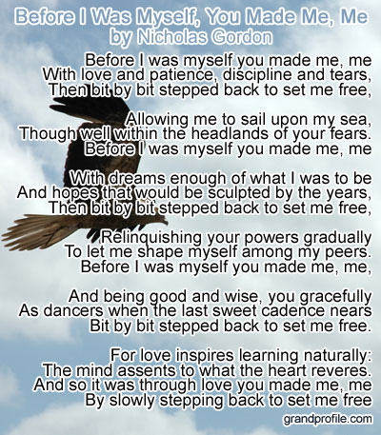

Page 6 of 13

Scripture Reading for June

Sunday, June 6 Sunday, June 13
Second Sunday after Pentecost Third Sunday after Pentecost
1 Sam 8: 4-11, (12-15), 16-20, (11:14-15) 1 Sam 15: 34- 16: 13 Ps 138 Ps 20
Gen 3: 8-15 Ezek 17: 22-24 and Ps 92: 1-4, 12-15
2 Cor 4: 13-5:1 2 Cor 5; 6-10, (11-13), 14-17
Mk 3: 20-35 MK 4: 26-34
God’s Will Flourishing

Sunday, June 20 Sunday, June 27
Fourth Sunday after Pentecost Fifth Sunday after Pentecost
1 Sam 17: (1a, 4-11, 19-23), 32-49 2 Sam 1; 1, 17-27
Ps 49 Ps 130
1 Sam 17: 57-18;5, 18; 10-16 Wisdof Sol 1: 13-15, 2: 23-24
Ps, 133 LM 3: 22-33
Job 38: 1-11 Ps 30
Ps 107: 1-3, 23-32 2 Cor 8; 7-15
2 Cor 8: 7-15 MK 5:21-43
Mk 4: 35-41 Healing Powers
Pushing the Boat Out

Page 7 of 13

Meeting Minutes / Reports
St. John’s United Church of Christ
Council Meeting Minutes
April 12, 2021

Council Members Present: Georgia Phelan, Miriam Guyor, Shari Faucher, Carolyn Hosford, Don Weichert, Pastor Ken Gadd
Absent: Katie Phelan

- Call to order: 6:35 p.m.

- Opening prayer: Pastor Ken

- Approval of Agenda: Motion to approve agenda by Don. Second by Carolyn. Carried.

- Minutes of last meeting: Motion to approve minutes of March 8, 2021 by Shari. Second by Carolyn. Carried.

- Standing Reports

- Treasurer’s Report: Motion by Shari to accept Treasurer’s Report as presented and to move One Great Hour of Sharing to a sub-category of Benevolence offerings on the Profit and Loss statement in the future. Second by Georgia. Carried.

- Prayer Group: no report until Health and Vitality meetings resume.

- Sunday School: no report until Health and Vitality meetings resume.
.
- Pastor’s Report

- Pastor Ken confirmed that all were happy with the new financial statement format.
- He was pleased with our Holy Week services using both St. James and St. John’s locations. The special music provided by Diane at these services went very well.
- Pastor has called all members in our Directory to touch base with them.
- It was a very busy month with Holy Week and also the Upper Room Discussion sessions.
- There was a lot of pastoral work recently with visitations, funerals, etc.

- Building and Grounds: Carolyn reported that the adjustments made to the ovens by the contractor did not help the heating issue. Georgia made the motion that we use CES as the contractor to purchase the needed two thermal couplings to repair the ovens. Second by Shari. Don abstained. Motion carried.
.
- Unfinished Business

- Annual meeting: TBD
- To-do list: TBD
- Draft use agreement: TBD
Page 8 of 13

- Record/History book update: No report at this time
- Rummage and Bake Sales. Dates have been set as Friday, May 14 from 9 a.m. to 5 p.m. and Saturday, May 15 from 9 a.m. to 3 p.m. Thursday Ma 13 is set up day. We need donated goods to sell. Don will contact our AA group and Miriam will contact TOPS group for donations. Georgia will post to the Marine City Facebook page to promote the sale and ask for donated goods.

- New Business

Don inquired as to whether we will continue offering scholarships to high school students in the future. We will offer one this year and hope to increase to the previous two scholarships in the future.

- Motion by Miriam to adjourn at 7:30 p.m. Second by Carolyn. Carried.

Closing Prayer: Carolyn

Next meeting: May 10 at 6:30 p.m.

Submitted by Miriam Guyor, Secretary

Page 9 of 13

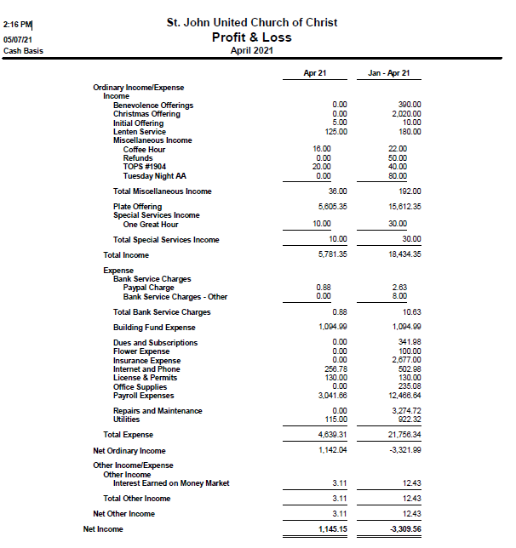

Page 10 of 13

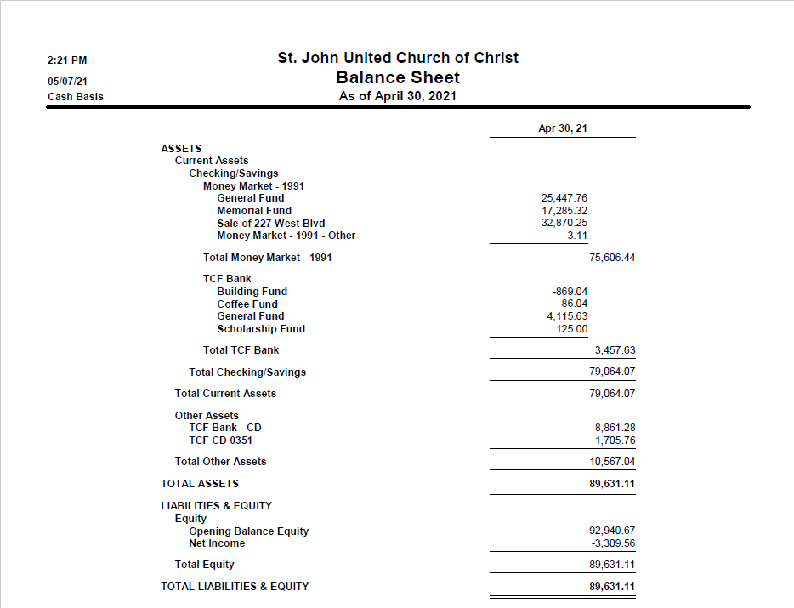

Page 11 of 13

Message from St. Johns Council President

From the Prez

I lost my list!!
I’m a list person. Due to a horrible memory, a life-long affliction, I write most everything down. So during our recent Rummage and Bake Sale, I made lists- including one of our volunteers. But it’s gone! This annoys me no end, but it is what it is.
So, instead of being able to thank each of you by name, I’m thanking all of you at once. Whether you baked, hauled, folded, sorted, set up/took down tables and tents, or any of the necessary chores, it was sincerely appreciated. AND- it resulted in a profit of $3,541.20 for St. John’s. $418 was from baked goods alone. Not too shabby! I DO remember my co-chairs, Miriam Guyor and Carolyn Hosford. They are wonderfully hard workers and do a great rendition of John Denver’s “Annie’s Song”, accompanied by a white stuffed animal. That sounds crazy in writing, so I guess witnessing this numerous times over the two days of the sale was necessary to truly appreciate how much fun running a rummage sale can be!
I’m pleased to announce this year’s scholarship recipients! The St. John’s award will go to Ian Blackstock, who will attend the University of Nebraska in Omaha. The Mary-Martha Guild award will go to Lorenzo Franco, who will attend Neumont College of Computer Science in Salt Lake City, UT. We hope to have them attend a Scholarship Service on either June 6 or 13, exact date still to be determined.
Another date you’ll want to note is August 15 when we’ll have our annual outdoor service with picnic following. Rain date is August 22. This event reminds me once again how fortunate we are to have this wonderful home for St. John’s, complete with our own picnic grounds!
With sadness, I share the passing of Joan Davidson in early May. Her Memorial Service will be on June 26 at Bower & Rose Funeral Home, Marine City. Visitation will be at 10:00 am, followed by the service at 11:00.
For those of you who haven’t made it back to in-person service yet, please consider it soon. We miss you!
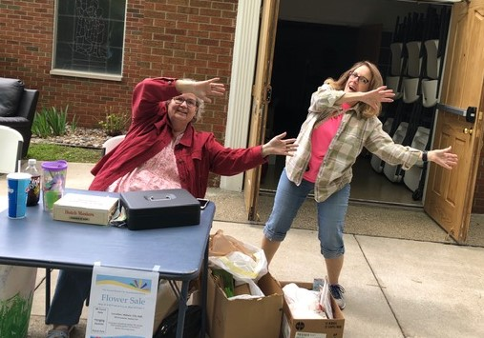
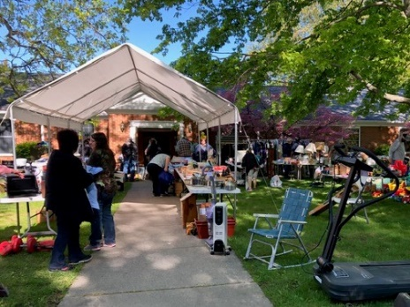
Georgia

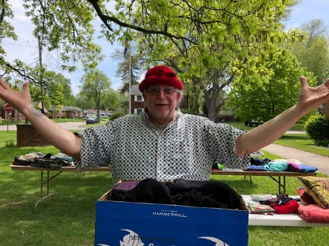
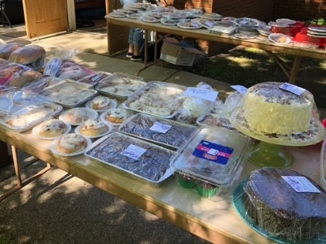

Page 12 of 13

June Events

Sunday, June 6 – Sunday Service with Holy Communion – 11:00am

Sunday, June 6 or 13 (TBD) – Scholarship Service – 11:00am.

Sunday, June 13 – Sunday Service – 11:00am

Monday, June 14 – In person Council Meeting – 6:30pm
Flag Day

Sunday, June 20 – Sunday Service with Holy Communion – 11:00am
Father’s Day

Sunday, June 27 – Sunday Service – 11:00am

Additional Activities

Outdoor Service and Picnic
Sunday, August 15 – 11:00 a.m. - Rain Date August 22nd at 11:00 a.m.

Sunday Services
Sunday Service is in person 11:00 a.m. Service is also available via online streaming on Sunday mornings at 11:00 a.m. If it is not available on our Facebook page, please try St. James’ - it is the exact same service. Both will be available to view as a video any time after the live streams. www.facebook.com/Stjohnsuccmarinecity or www.facebook.com/St.James-United-Church-of-Christ-10150090210425008.

Council Meetings
Church Council’s next meeting is June 14th at 6:30 p.m. in the Community Room.

Sunday School
Sunday School will resume in the fall.

Health & Vitality Meetings
We’re prepping to restart this important function! Watch for details.

Coffee Donations
There is a container on the counter by the coffee pots for freewill donations to help pay for the cost of Coffee Hour. Any help will be greatly appreciated.

Annual Meeting
St. John’s UCC Annual Meeting; date pending.

St. Johns United Church of Christ
527 N. William Street
Marine City, MI 48039
Phone: (810) 765-5371
E-mail: kgadd@stjohnsmarinecity.org

We’re on the Web!
stjohnsmarinecity.org

JUNE
NEWSLETTER

