St. Johns United Church of Christ
527 N. William Street, Marine City, MI 48039

Contents
News from Pastor Ken 1
Pastor Ken News Cont. 2
Birthdays 3
Anniversaries 3
Worship Ministry 3
Military Prayer List 3
Prayers Needed 3
Kid’s Page 4
Memorial Day Poem 5
Scripture Readings 6
Reports 7-10
Council President 11
Rummage Sale 12
Additional Activities 13

I know that everyone has a story for when the weather has been worse or better or different but…. this has been just an odd winter / spring for weather. There was a week when it started in the 60’s and ended in the teens. There has been snow in the middle of April. We have had days that included a little winter and summer all in a day of spring. This weather has been teasing us for over a month.

In spite of it all, I cannot believe how excited I am about the possibility of spring. I cannot wait to spend more time in the yard and in the garden. The gardens seem to be alive already. It is like they could not wait any longer, regardless of the weather. I love watching the gardens come alive.

Taking care of the garden has become a series of great life lessons for me. One of those lessons is that I am still learning to balance the hard work of gardening with remembering to take time to enjoy the garden. I find seeking that balance an interesting metaphor for life. We sometimes get so busy doing life that we forget to enjoy life. However, that being said, I am actually thinking about a couple new garden ideas for this year. They are always a work in progress. As always, we will see how the plan unfolds.

I love the sight, sound and smell of spring, full sensory overload. The garden in early spring serves as a wonderful reminder of all the miracles of life. Just like in our own lives, there is a lot of amazing stuff going on, but because it often happens just below the surface, we sometimes forget to notice it. There exists an amazing opportunity for transition, both in our yards and in our lives. Often where and when we least expect it.

News from Pastor Ken
https://www.facebook.com/Stjohnsuccmarinecity/

The purpose of a newsletter is to provide specialized information to a targeted audience. A school newsletter can be a great way to develop a strong relationship with parents.
First choose a short title for your newsletter— something like "School News," or “Back to School.” As you choose the title, also take time to think about the newsletter’s theme. What important messages do you want to send parents and families?
Next, establish how much time and money you can spend on your newsletter. These factors will help determine how frequently you publish the newsletter and its length.
Use the body of your school newsletter to keep parents apprised of major assignments and class events, as well as any of school district news. Also share news for specific grade levels, and tell parents about upcoming events, new faculty, and school policies.

Dear Parents

So this Easter season I hope you continue to look for the miracles wherever and whenever they may appear, regardless of how big or how small they may be. Remember, this is truly a season of hope and resurrection. As I work in the garden and experience the joy of new life, my hope is that each of us has the opportunity to experience new life spiritually as well.

With all of challenges that life brings, both in the world and in some of our own homes, it is sometimes hard to remember that God is with us always and at work in our lives. I think that is one of the true miracles of Easter and spring. We are reminded with every winter there comes a season of rebirth and new hope. Sometimes it just takes a while for us to notice it.

So, look around, take a deep breath or two, okay, maybe for some of us three, and know that God is at work in your life right now. Even if you cannot see it or feel it yet, God is preparing you for a personal Easter transformation.

Remember that whoever you are and wherever you are on life’s journey, you are held in God’s unconditional love, boundless mercy, and unending grace and there is a place for you here.

And remember, be kind to yourself.
Take care and be well, Peace
Ken

**Live streaming of Sunday Services will continue at 9:00am on the St. James Facebook page and St. Johns Sunday Services will continue at 11:00am on the St. Johns Facebook page. Both will be available as a video any time after the live streams.**

**Live streaming of Sunday Services will continue at 9:00am on the St. James Facebook page.**
Live streaming of Sunday Services will continue at 11am. from St. John’s Facebook page.

Pastor Ken Newsletter Continued
Page 2 of 13
Page 3 of 13

Happy Birthdays in May
Happy Anniversaries in May
5-2 Judy O’Brien
5-16 Irene Lindeborg

5-4 Brenda & Thomas Fisher

Prayers For ……

Claudette, Linda, Wayne B., Shirley, Carole, Deborah, Karen, Keith, Terry, Janette, Barb, David, Lynn, Rita, Nikki, Vito, Doris, George, Ralph, Sue, Katie, Frazer, Lee, Arnie, Tom, Jennifer, Joy, Sally, Kirsten, Tina, Kathy, Vincent, Tamara, Dort, Don, Lois, Trisha, Harvey, Tom, Brenda, Bernetta, Joe, Jim, Prange Family, Ben H., Michelene, Families of St. John & St. James

Military Prayer List
I will be including a list in the newsletter of our men and women in the military, to acknowledge those who serve and to pray for their safety. Please submit your love one’s, family member or friend’s name, rank, and branch of service to be placed
on the list.

Josh Bieske Staff Sgt. US Air Force
Alex Tite Private US Army
Joshua Bieske Sgt. First Class US Air Force

Worship Ministry

Volunteers Needed
Please sign-up
Please consider signing up for the ministries of Usher/Greeter, Liturgists, Communion Servers, and Altar Care.

Page 4 of 13

Kid’s Page

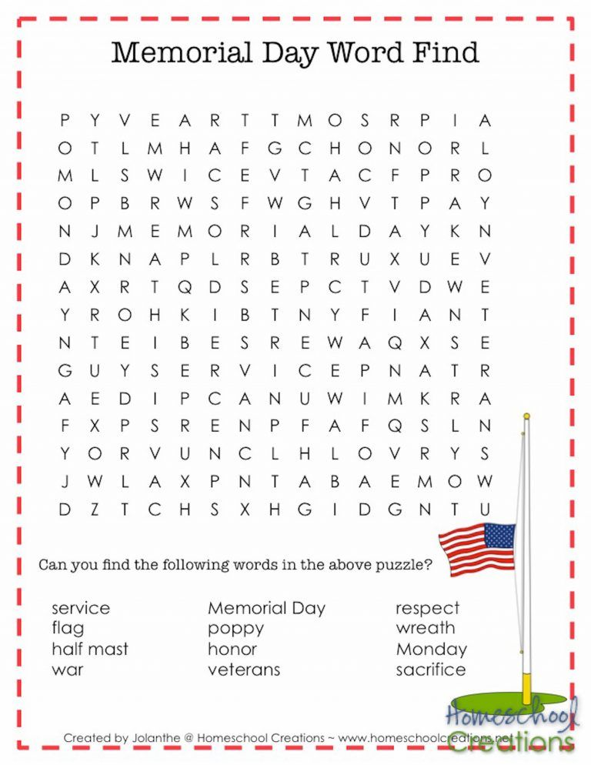
Page 5 of 13

Memorial Day

A tribute to our fallen soldiers

Page 6 of 13

Scripture Reading for May

Sunday, May 2 Sunday, May 9
Fifth Sunday of Easter Sixth Sunday of Easter
Acts 8: 26-40 Acts 10: 44-48 Ps 22: 25-31 Ps 98
1 Jn 4: 7-21 1 Jn 5: 1-6
Jn 15: 1-8 Jn 15: 9-17
Abiding In Love Friends Together

Sunday, May 16 Sunday, May 23
Seventh Sunday of Easter Pentecost
Acts 1: 15-17, 21-26 Acts 2: 1-21 or Ezek 37: 1-14
Ps 1 Ps 104: 24-34, 35b
Jn 5: 9-13 Rom 8: 22-27 or Acts 2:1-21
Jn 17: 6-19 Jn 15: 26-27, 16: 4b-15
Guided in Prayer Spirit for All

Sunday, May 30
Trinity Sunday
Isa 6: 1-8
Ps 29
Rom 8: 12-17
Jn 3: 1-17
Mysterious Encounter

Page 7 of 13

Meeting Minutes / Reports
St. Johns United Church of Christ
Council Meeting Minutes DRAFT
March 8, 2021

Council Members: Georgia Phelan, Carolyn Hosford, Don Weichert, Shari Faucher, Katie Phelan, Miriam Guyor, Pastor Ken Gadd

- Call to order: 6:34 p.m.

- Opening prayer: Pastor Ken

- Roll call: Absent – Georgia, Don
Today’s presiding officer: Miriam Guyor

- Approval of Agenda: Motion to approve agenda by Shari. Second by Carolyn. Carried

- Minutes of last meeting: Motion to approve minutes by Carolyn. Second by Shari. Carried.

- Standing Reports

- Treasurer’s Report: Motion to accept Treasurer’s Report for January and February 2021 by Carolyn. Second by Miriam. Carried.

- 2021 Rummage Sale: Motion by Shari to have Council sponsor the Rummage Sale this year. Second by Katie. Carried.

- Prayer Group: Table until next month.

- Sunday School: Motion by Miriam to further suspend Sunday School until fall and look at curriculum over the summer. Second by Carolyn. Carried.

- Pastor’s Report: Pastor Ken reports that he is content. He is anxious to see more attendance. He is also pleased with the participation in the ZOOM Upper Room discussion group.

- Building and Grounds
- Carolyn explained that the ovens do not work properly. Shari made the motion that Carolyn contact CES Commercial Equipment Services for a service call for the ovens. Second by Katie. Carried.
- Parking lot door repair will be revisited in the future.

Page 8 of 13

- Church Groups: Groups will stay on the agenda as they are now until they are reorganized by the five ministry areas as determined by the Health and Vitality Committee.

- Unfinished Business

- Annual Meeting: Tabled/TBD

- Insurance bills: Shari made the motion that all insurance bills (Property and Liability $2431 and Worker’s Comp $246) be paid. Second by Carolyn. Carried.

- Liturgists, Ushers and Greeters: those in attendance have signed up

- Record/History book update: Tabled

- Close church for a week for floor cleaning: TBD

- To-do list: TBD

- Draft use agreement: No action taken

- New Business

- Marine City High School Scholarships
Motion by Miriam that Council will award one Scholarship for $250. Second by Shari. Carried.

- Motion by Carolyn to adjourn at 7:35 p.m. Second by Shari. Carried.

Closing prayer: Pastor Ken

Submitted by Miriam Guyor, Secretary

Page 9 of 13

March 2021 Treasurer’s Report
St. John United Church of Christ
Profit & Loss
Mar 21
Ordinary Income/Expense
Income
Benevolence Offerings 390.00
Initial Offering 5.00
Lenten Service 45.00
Miscellaneous Income
Coffee Hour 6.00
TOPS #1904 20.00
Total Miscellaneous Income 26.00
Plate Offering 3,602.00
Total Income 4,068.00

Expense
Dues and Subscription 59.98
Payroll Expense 6,158.32
Repairs & Maintenance 666.72
Utilities 357.32
Total Expense 7,242.34

Net Ordinary Income -3,174.34

Other/Income / Expense
Other Income
Interest Earned on Money Market 3.21
Total Other Income 3.21

Net Other Income 3.21

Net Income -3,171.13

Page 10 of 13

St. John United Church of Christ
Balance Sheet

Mar 31, 21
ASSETS
Current Assets
Checking/Savings
Money Market - 1991
General Fund 25,447.76
Memorial Fund 17,285.32
Sale of 227 West Blvd 32,870.25
Total Money Market - 1991 75,603.33
TCF Bank
Building Fund 225.95
Coffee Fund 70.04
General Fund 1,894.60
Scholarship Fund 125.00
Total TCF Bank 2,315.59
Total Checking/Savings 77,918.92
Total Current Assets 77,918.92

Other Assets
TCF Bank - CD 8,861.28
TCF CD 0351 1,705.76
Total Other Assets 10,567.04
TOTAL ASSETS 88,485.96

LIABILITIES & EQUITY
Equity
Opening Balance Equity 92,940.67
Net Income -4,454.71
Total Equity 88,485.96
TOTAL LIABILITIES 88,485.96

Page 11 of 13

Message from St. Johns Council President

Happy May! Like Pastor Ken, I’m a gardener and truly enjoy this time of the year. It’s so full of promise!

I feel this rosy outlook carry over into my church life, too. As we progress through 2021, I look forward to not just seeing everyone (I REALLY miss you guys!), but to picking up some of our activities, too. For me, that means our Health and Vitality group in particular. We were just getting going with our plans for St. John’s! We are drawing nearer to that point, so please be thinking how you may participate as we identify what is important to St. John’s, to each of us, and for our calls to ministry.
(Drum roll please!) It is time for our Annual Rummage and Bake Sale on May 14 and 15th! The flyer for this event will be in this newsletter; please pull it out and share it! We also need your help rounding up “product” to sell. Don’t be afraid to ask family and friends for their contributions. If someone needs help with transporting items, please let me know at 586-242-2410 or gphelan1@comcast.net. We can also arrange to meet you at church for drop offs if you don’t bring them on Sundays. And don’t forget BAKED GOODS for our Bake Sale! This event will be very important in helping us meet our financial obligations here at St. John’s- please do what you can. Carolyn, Miriam and I thank you

Speaking of financial obligations, our ovens just had about $1,000 of repairs done. This amount generated some discussion at the Church Council meeting, but ultimately it was decided to make this investment. We need these ovens for our Annual Chili Potato Dinner and we hope to host more events in the future. Additionally, once gatherings are again safe, we hope to use our commercial kitchen as a source of income both from catering income and for rental events like parties and weddings. We have a beautiful facility with a wonderful outdoor space- we hope to use it more.
See you at St. John’s!

Georgia

Page 12 of 13

St. John’s UCC Annual
______________________________________________________________________________________ Rummage &
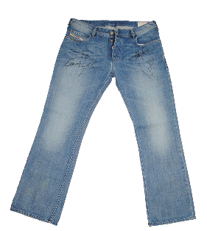
Bake Sale
This Photo by Unknown Author is licensed under CC BY-NC
This Photo by Unknown Author is licensed under CC BY
Friday, May 14
9 am-5 pm
Saturday, May 15
9 am-3 pm

527 N. William St., Marine City
Multi-family, household, furnishings, clothing, more

“Name Your Own Price” pricing
All proceeds benefit St. John’s United Church of Christ
_________________________________________________________

Page 13 of 13

May Events

Sunday, May 2 – Sunday Service with Holy Communion – 11:00am

Monday, May 10 – In person Council Meeting – 6:30pm

Thursday, May 13 - Rummage Sale – Set-up – St. Johns

Friday, May 14 - Rummage Sale & Bake Sale - 9am – 5pm

Saturday, May 15 - Rummage Sale & Bake Sale - 9am – 3pm

Sunday, May 16 – Sunday Service with Holy Communion – 11:00am

Sunday, May 30 – Sunday Service with Healing – 11:00am

Monday, May 31 – Memorial Day

Additional Activities
Sunday Services
Sunday Service is now in person 11:00am. We are still trying to provide streaming service on Sunday mornings at 11:00am. If it is not available on our Facebook page, please try St. James’- it is the exact same service. Both will be available to view as a video ant time after the live streams.

Council Meetings
Church Council is resuming in person meetings on the second Monday each month. Their next meeting is May 10th at 6:30pm.

Sunday School
Sunday School will resume in the fall.

Health & Vitality Meetings
No meetings until further notice.

Coffee Donations
There is a container on the counter by the coffee pots for freewill donations to help pay for the cost of Coffee Hour. Any help will be greatly appreciated.

Annual Meeting
St. John’s UCC Annual Meeting that is usually held in January has been postponed until further
notice.

St. Johns United Church of Christ
527 N. William Street
Marine City, MI 48039
Phone:
(810) 765-5371
E-mail:
kgadd@stjohnsmarinecity.org
We’re on the Web!
stjohnsmarinecity.org

MAY
NEWSLETTER

