St. Johns United Church of Christ
527 N. William Street, Marine City, MI 48039

Contents
News from Pastor Ken 1
Pastor Ken News Cont. 2
Birthdays 3
Anniversaries 3
Worship Ministry 3
Military Prayer List 3
Prayers Needed 3
Kid’s Page 4
Easter Poem 5
Scripture Readings 5
Reports 6-9
Council President 10
Additional Activities & April Events 11
Notices 11
Rummage Sale 12

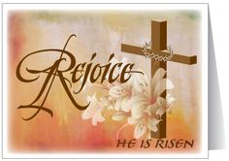

It just seems that everyone I talk to lately is experiencing winter fatigue. Even my consulting client that has had a banner year doing over a million dollars last year in corporate snowplowing and landscaping (mostly snowplowing) has informed me that he is “so done with winter.”

Many of you have commented or inquired about Easter being early this year. Not really. It just came rather late last year. We have had both earlier and later Easters. Well here is how it was decided. We can thank our Pagan friends in part for this. In 325CE the Council of Nicaea established that Easter would be held on the first Sunday after the first full moon occurring on or after the vernal equinox. From that point forward, the Easter date depended on the ecclesiastical approximation of March 21 for the vernal equinox.

Here is what I know for sure. Spring and Easter are here even though it may not feel like spring at this moment. I heard some folks discussing how many robins that have already seen (none at my house yet) and my neighbor mentioned that she already has crocus’, and I noticed little green sprouts popping up from beneath the cold earth as I walked through thinking about my gardens. It must be spring!!

As we finish this Lenten season the end of March and enter Easter, remember it is just like the transition from winter into spring. During what seems to be the endless cold dark days of winter, we start to experience the new life that rises up from what we were once sure was dead. That is what the Easter season offers us as well, to seek and experience new life, new life in our congregation and new life for ourselves.

News from Pastor Ken
https://www.facebook.com/Stjohnsuccmarinecity/

The purpose of a newsletter is to provide specialized information to a targeted audience. A school newsletter can be a great way to develop a strong relationship with parents.
First choose a short title for your newsletter— something like "School News," or “Back to School.” As you choose the title, also take time to think about the newsletter’s theme. What important messages do you want to send parents and families?
Next, establish how much time and money you can spend on your newsletter. These factors will help determine how frequently you publish the newsletter and its length.
Use the body of your school newsletter to keep parents apprised of major assignments and class events, as well as any of school district news. Also share news for specific grade levels, and tell parents about upcoming events, new faculty, and school policies.

Dear Parents

This Lenten season was a powerful season for me as I hope it was for you, filled with reflection, preparation and discernment. Many of us spent time this Lenten season considering our own personal journey through the wilderness into Jerusalem. We prayed about what we bring to the cross and more importantly, what resurrection and transformation we have come to expect in our own lives this Easter. Over the past weeks, we have been talking about discovering the Christ within us, to be the resurrected, living Jesus we know God has called us to be.

As we come into spring, expect the miracle of new life. Expect to be transformed. Again, that is what Easter is all about. Some miracles are large and some are small, some require that we look for them. A number of them even require that we work to reveal them. However, if we do look, if we keep expecting them and are willing to do what God asks us to do; those miracles will just keep coming.

I am excited about what this Easter season has in store for us all, personally and as a community in Christ. I encourage you to keep your heart, mind and spirit open. Let us plan together, pray together, and work together. Let us prepare to be transformed.

I invite you all to participate in the Holy week services including Maundy Thursday, Good Friday, the Great Easter Eve Vigil and of course Easter morning Communion service. Invite those you have missed to join us and share in this time of personal transformation and renewal.

As always, who ever you are and wherever you are at on life’s journey, you are always welcome here.

Take care and be well, Peace
Pastor Ken

**Live streaming of Sunday Services will continue at 9:00am on the St. James Facebook page**

**Live streaming of Sunday Services will continue at 9:00am on the St. James Facebook page.**
Live streaming of Sunday Services will continue at 11am. from St. John’s Facebook page.

Pastor Ken Newsletter Continued
Page 2 of 12
Page 3 of 12

Happy Birthdays in April
Happy Anniversaries in April
4-11 Megan Hincherick
4-13 Nelson Prange
4-16 Tom Kaufman
4-16 James Wood
4-20 Donna Beardon
4-16 Tamara & tom Gorence
4-29 Lynn & Steve Andrews

Prayers For ……

Ted S., Jim W., Joy, Dort, Don, Lois, Tom, Brenda, Bill, Jim, Karen, Steve, Marge, Marion, Debbie, Ben H., Michelene D., Jim, Rebecca, Trish, Bea, Harvey, Lynn, Gordie, Rita, Don Patti, Families of St. John & St. James
Ted S. Jim
Joy Dort
Don Lois
Tom Brenda
Bill Trish
Karen Steve
Marge Marion
Debbie Ben H.
Michelene D. Rebecca
Bea Harvey
Lynn Gordie
Rita Don
Patti Families of St. John & St. James

Military Prayer List
I will be including a list in the newsletter of our men and women in the military, to acknowledge those who serve and to pray for their safety. Please submit your love one’s, family member or friend’s name, rank, and branch of service to be placed
on the list.

Josh Bieske Staff Sgt. US Air Force
Alex Tite Private US Army
Joshua Bieske Sgt. First Class US Air Force

Worship Ministry

Volunteers Needed
Please sign-up
Please consider signing up for the ministries of Usher/Greeter, Liturgists, Communion Servers, and Altar Care.

Page 4 of 12

Kid’s Page

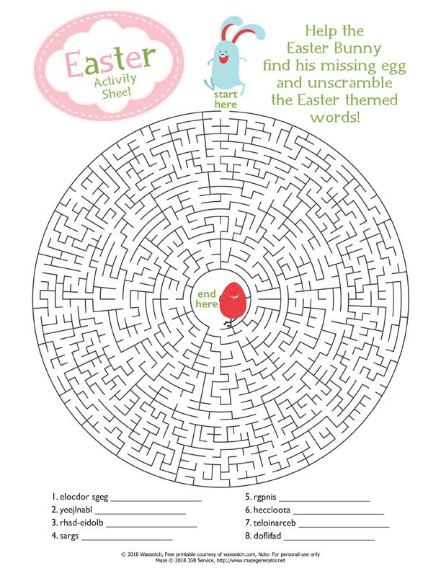

Page 5 of 12

Easter Poem!!

Scripture Reading for April

Sunday, April 4 Sunday, April 11
Easter Sunday Second Sunday of Easter
Acts 10 ; 34-43 or Isa 25 : 6-9 Acts 4: 32-35
118 ; 1-2, 14-24 Ps 133
1 Cor 15 : 1-11 or Acts 10 : 34-43 1 Jn 1: 1-2: 2
Jn 20: 1-18 or Mk 16: 1-8 Jn 20: 19-31
Now What? Marks of Faith

Sunday, April 18 Sunday, April 25
Third Sunday of Easter Fourth Sunday of Easter
Acts 3: 12-19 acts 4: 5-12
Ps 4 Ps 23
1 Jn 3: 1-7 1 Jn 3: 16-24
Luke 24: 34b - 48 Jn 10: 11-18
Christ Among Us Enfolded by Love

Page 6 of 12

Meeting Minutes / Reports
St. Johns United Church of Christ
Council Meeting MINUTES via Zoom
February 8, 2021
Council Members Present: Georgia Phelan, Carolyn Hosford, Don Weichert, Shari Faucher, Katie Phelan, Miriam Guyor, Pastor Ken Gadd.
- Call to order: 6:34 p.m.
- Opening prayer: Pastor Ken
- Roll Call: All present
- Approval of Agenda: Motion to approve agenda by Shari. Second by Carolyn. Motion carries.
- Minutes of last meeting: Motion to approve minutes by Don. Second by Shari. Motion carries.
- Standing Reports
Treasurer's Report:
Motion by Shari to table this report due to incomplete accounting changeover. Second by Miriam. Motion carries.
The amended 2021 Budget has been disbursed.
B. Mary Martha Guild: nothing to report
c. Sunday School: nothing to report
  - Pastor's Report:
Ash Wednesday service is February 17 at 7:00 p.m. at St. James.
ll. St. Johns members have been in attendance at St. James.
Pastor Ken suggests adopting the Mission Statement currently used by St. James.
A note was received from Lynn Andrews thanking us for allowing her to be a council member during the last term.
A Zoom discussion on The Upper Room will be held the first four Wednesdays in March.
  - Building and Grounds:
Close church for a week for floor cleaning: TBD ll. To-do list: TBD
Draft use agreement (Ken): TBD
- Unfinished Business:

Page 7 of 12

Record/History Book: There are numerous gaps in the records. Shari is working to track records. Ken has some, and other members will be asked for more information. Shari will work on the book at home, then return it to church.
B. Annual Meeting: TBD
C. Church closing/reopening: Motion by Miriam to contact members using the Emergency Call List to notify all of Sunday services resuming on February 28 with masks and social distancing strongly encouraged. Second by Shari. Motion carries.
It was suggested that during these calls, inform all of Upper Room discussion in March and provide Ken's email.
Ken will inform musicians of reopening date and Georgia will talk to our custodian.
- New Business:
Envelope order. The new order will be for 51 boxes instead of 70.
B. The next Council meeting will be held on March 8 at 6:30 at the church. Don will preside as Georgia will be in Florida.
- Adjournment: Motion by Shari to adjourn at 8:05 p.m. Second by Don. Motion carries.
Closing prayer by Don.
Submitted by Miriam Guyor, Secretary

Page 8 of 12

February 2021 Treasurer’s Report
St. John United Church of Christ
Profit & Loss
Feb 21
Ordinary Income/Expense
Income
Lenten Service 10.00
Plate Offering 4,240.00
Special Services Income
One Great Hour 20.00
Total Special Services Income 20.00
Total Income 4,270.00

Expense
Dues and Subscription 45.00
Flower Expense 100.00
Insurance Expense 2,677.00
Internet and Phone 123.10
Office Supplies 235.08
Repairs & Maintenance 225.00
Total Expense 3,405.18

Net Ordinary Income 864.82

Net Income 864.82

Page 9 of 12

St. John United Church of Christ
Balance Sheet

Feb 28, 21
ASSETS
Current Assets
Checking/Savings
Money Market - 1991
General Fund 25,441.65
Memorial Fund 17,285.32
Sale of 227 West Blvd 32,870.25
Total Money Market - 1991 75,597.22
TCF Bank
Building Fund 1,050.95
Coffee Fund 64.04
General Fund 4,205.69
Scholarship Fund 125.00
Total TCF Bank 5,445.68
Total Checking/Savings 81,042.90
Total Current Assets 81,042.90

Other Assets
TCF Bank - CD 8,861.28
TCF CD 0351 1,705.76
Total Other Assets 10,567.04
TOTAL ASSETS 91,609.94

LIABILITIES & EQUITY
Equity
Opening Balance Equity 92,940.67
Net Income -1,330.73
Total Equity 91,609.94
TOTAL LIABILITIES 91,609.94

Page 10 of 12

Message from St. Johns Council President

April! At the beginning of January, it seemed like forever to get to Easter, but here we are.
I was out of state for March and am anxious to rejoin my family in Christ here at St. John’s. I was so happy to realize I’d be back for Easter service, I signed up to be liturgist before I even left
Please see the calendar page for dates and times of Holy Week services and activities.
We’re happy to announce our 2021 Rummage Sale will take place on May 14 and 15 this year. Chaired by Council members Carolyn Hosford, Miriam Guyor and Georgia Phelan, it will run from 9 a.m.-5 p.m. each day. Thursday will be set up day. If you would like to help out, please get your name and availability to one of us. Please help us accumulate a great selection of goods to offer. They can be brought to the Community Room at any time. If you need access at a certain time, please let us know and one of us will be available. Please try to get it here, but if you have no way to get items moved, let us know.
We will also feature a Bake Sale, so shake out that apron and dust off your favorite recipes. Goodies can be dropped off on Thursday while we’re there prepping or anytime before or during the sale on Friday. Fresh goods would be appreciated on Saturday, too.
Council is pleased to be able to offer a $250 scholarship to a graduating senior at Marine City High School this year. The Mary-Martha Guild is offering one for $300. I’ll let you know of the recipients when they have been determined.
The decision has been made to resume Sunday School in the fall, as by the time we got reorganized now, school would only be held for a few weeks before we break for summer. I know we all look forward to our younger members joining us again.
Our Annual Meeting will still be held; date to be determined.
I hope everyone is remaining vigilant as we attempt to beat down Covid. It’s a joyous thing that we are able to worship in person again, but let’s remember that people, including locally, are still getting sick every day. So, please, let’s take care of all God’s children, including ourselves, for just a while longer.
My favorite “nugget” from Ken’s service this week (3/21/21): “We are not humans on a spiritual journey; we are spiritual beings on a human journey.” Hmmm…. God’s love to you and yours this month!
Georgia

Page 11 of 12

St. John’s UCC Annual
__________________________________________________________________________________________
Rummage &
Bake Sale
This Photo by Unknown Author is licensed under CC BY-NC
This Photo by Unknown Author is licensed under CC BY
Friday, May 14
9 am-5 pm
Saturday, May 15
9 am-3 pm

527 N. William St., Marine City
Multi-family, household, furnishings, clothing, more

“Name Your Own Price” pricing
All proceeds benefit St. John’s United Church of Christ
_________________________________________________________

April Events
Page 12 of 12

Thursday, April 1 – Maundy Thursday Service – at St. James 7pm

Friday, April 2 - Good Friday Services – St. James Service 12:00pm, Stations of
the Cross following service
St. Johns Service at 7pm, Stations of the Cross following service

Saturday, April 3, Holy Saturday Service at James – 7pm

Sunday, April 4 – Sunday Service with Holy Communion – at James - 9:00am

Monday, April 12 – In person Council Meeting – 6:30pm

Sunday, April 11 – Sunday Service – 11;00am

Sunday, April 18 – Sunday Service with Holy Communion – 11:00am

Saturday, April 24 – Euchre at St. James – 6:30pm

Sunday, April 25 – Sunday Service – 11:00am

Thursday, May 13 - Rummage Sale – Set-up – St. Johns

Friday, May- Rummage Sale & Bake Sale - 9am – 5pm

Saturday, May- Rummage Sale & Bake Sale - 9am – 3pm

Additional Activities
Sunday Services
Sunday Service is now in person 11:00am. We are still trying to provide streaming service on Sunday mornings at 11:00am. If it is not available on our Facebook page, please try St. James’- it is the exact same service.

Council Meetings
Church Council is resuming in person meetings on the second Monday each month. Their next meeting is April 12th at 6:30pm.

Sunday School
Sunday School will resume in the fall.

Health & Vitality Meetings
No meetings until further notice.

Coffee Donations
There is a container on the counter by the coffee pots for freewill donations to help pay for the cost of Coffee Hour. Any help will be greatly appreciated.

Annual Meeting
St. John’s UCC Annual Meeting that is usually held in January has been postponed until further
notice.

St. Johns United Church of Christ
527 N. William Street
Marine City, MI 48039
Phone:
(810) 765-5371
E-mail:
kgadd@stjohnsmarinecity.org
We’re on the Web!
stjohnsmarinecity.org

APRIL
NEWSLETTER

