St. Johns United Church of Christ
527 N. William Street, Marine City, MI 48039

Contents
News from Pastor Ken 1
Pastor Ken News Cont. 2
Coffee Donations 2
Mary Martha Mtg Chg. 2
Let’s Recycle 2
Birthdays 3
Worship Ministry 3
Military Prayer List 3
Prayers Needed 3
Kid’s Page 4
Memorial Day Poem 5
Minutes/Reports 6 – 9
May Activities 10
Additional Activities 11
Scripture Readings 12

Is it me or has this has been a strange year for weather? There have been several days of near 70-degree weather. We have had days that included a little winter and summer all in a day of spring. This weather has been teasing us for over a month.

It makes me think that mother nature is struggling to let go of her wintry past and even though she wants spring to happen she struggles with making the commitment to spring. So she gets stuck between the two. Can’t quite let go of the things she likes about the past and has anxiety about what the unknown spring can bring. In the meantime, it makes a bit of a mess of what’s going on today weather-wise. Interestingly, that reminds me of my life journey sometimes. If I try too hard to hold on to the past even though some of it was unpleasant while at the same time being anxious about committing to the future even though in my heart I am aware of its wonderful possibilities I have a tendency to not allow myself to experience the full potential of the present moment.

All that being said, I cannot believe how excited I am about the possibility of spring. I cannot wait to spend more time in the yard and in the garden. The gardens seem to be coming alive already. It is like they could not wait any longer. I love watching the gardens come alive.

Taking care of the garden has become a series of great life lessons for me. One of those lessons is that I am still learning to balance the hard work of gardening with remembering to take time to enjoy the garden. I find seeking that balance an interesting metaphor for life. We sometimes get so busy doing life that we forget to enjoy life. However, I am actually thinking about a couple new garden ideas for this year. They are always a work in progress. Once again, we will see how the plan unfolds.

https://www.facebook.com/Stjohnsuccmarinecity/

News from Pastor Ken

The purpose of a newsletter is to provide specialized information to a targeted audience. A school newsletter can be a great way to develop a strong relationship with parents.
First choose a short title for your newsletter— something like "School News," or “Back to School.” As you choose the title, also take time to think about the newsletter’s theme. What important messages do you want to send parents and families?
Next, establish how much time and money you can spend on your newsletter. These factors will help determine how frequently you publish the newsletter and its length.
Use the body of your school newsletter to keep parents apprised of major assignments and class events, as well as any of school district news. Also share news for specific grade levels, and tell parents about upcoming events, new faculty, and school policies.

Dear Parents

Page 2 of 12
I love the sight, sound and smell of spring, full sensory overload. The garden in early spring serves as a wonderful reminder of all the miracles of life. Just like in our own lives, there is a lot of amazing stuff going on, but because it often happens just below the surface, we sometimes forget to notice it. There exists an amazing opportunity for transition, both in our yards and in our lives. Often where and when we least expect it.

So this Easter season I hope you continue to look for the miracles wherever and whenever they may appear, regardless of how big or how small they may be. Remember, this is truly a season of hope and resurrection. As I work in the garden and experience the joy of new life, my hope is that each of us has the opportunity to experience new life spiritually as well.

With all of challenges that life brings, both in the world and in some of our own homes, it is sometimes hard to remember that God is with us always and at work in our lives. I think that is one of the true miracles of Easter and spring. We are reminded with every winter there comes a season of rebirth and new hope. Sometimes it just takes a while for us to notice it.

So look around, take a deep breath or two, and know that God is at work in your life right now. Even if you cannot see or feel it yet, God is preparing you for a personal Easter transformation.

Remember that whoever you are and wherever you are on life’s journey, you are held in God’s unconditional love, boundless mercy, and unending grace and there is a place for you here.

Take care and be well, Peace
Ken

Mary Martha Meeting Change
The Mary Martha Guild will be changing their monthly meeting from the second Thursday to the second Wednesday of the month. Meeting time will remain at 12:30pm.
Coffee Donations
There is a container on the counter by the coffee pots for freewill donations to help pay for the cost of Coffee Hour.
Any help will be greatly appreciated.
Let’s Recycle
Watch for the new blue recycling bins at St. John’s! We will be recycling paper (weekly service programs included) and other paper. Look for that bin near the doors to the Sanctuary. We’ll also be recycling plastic, like water bottles and plastic cups. That bin will be near the coffee station. Let’s tread lightly on God’s earth- help us go green at St. John’s and recycle your paper and plastic!

Pastor Ken Newsletter Continued

Military Prayer List
I will be including a list in the newsletter of our men and women in the military, to acknowledge those who serve and to pray for their safety. Please submit your love one’s, family member or friend’s name, rank and branch of service to be placed
on the list.

Josh Bieske Staff Sgt. US Air Force
Alex Tite Private US Army

Happy Birthdays in May
Page 3 of 12
5/4 Tom Fisher
5/25 Jimmy Galvin

Worship Ministry

Volunteers Needed
Please sign-up

Please consider signing up for the ministries of Usher/Greeter, Liturgists and Altar Care.

Prayers For ……

Debbie Marion
Don & Lois Judy L.
Jerry Brenda
Tom Ken
James Cheryl
Shelley Victor
Carrie Joe Jr.
Jim & Karen Bill
Harvey Joy
Bobby Steve & Marge, Gordie & Rita Jim
Flemming Family Helen
Diane Loretta
Sandy & Bob Tom
Reuben John
Families of St John & St James.

Page 4 of 12
Kid’s Page

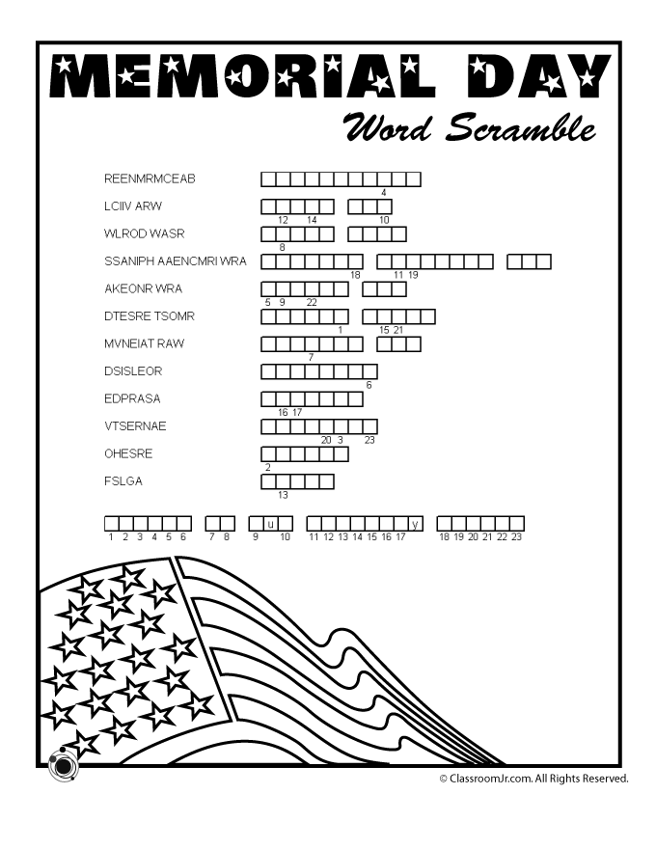
Page 5 of 12
Memorial Day Poem

Meeting Minutes / Reports
Page 6 of 12
St. John’s United Church of Christ
Council Meeting
March 11, 2019

Present: Rev. Ken Gadd, Dorothy Schultz, Carolyn Hosford, Loretta Prange,
Lynn Reh, Lynn Andrews
Absent: Georgia Phelan

Call to order at 6:45p.m. Opening prayer by Ken Gadd

- Minutes of the February 11, 2019 meeting presented by Lynn Andrews.
Motion by Dorothy to accept minutes as amended. Second by Carolyn.
Carried.

- Reports
- Treasurers Report presented by Dorothy. Motion by Lynn A. to accept report as presented. Second by Carolyn. Carried.
- Financial Secretary’s Report presented by Loretta. Motion by Carolyn to accept report as presented. Second by Lynn A. Carried.
- Mary Martha Guild
- Cookbooks still available for $10, group will try to sell leftovers at the rummage sale.
Lynn Reh will take home memorial book to update and organize.
- There will be a container put out on Sunday morning for a free will donation to be put toward coffee hour supplies.
- Quotes received for the window treatments by Dave Endres and JC Penney. Leaning toward Dave Endres, but it will need to have a congregational vote. Meeting on March 31 to approve. Motion by Dorothy. Second by Carolyn. Carried.
- Sunday School
Still waiting for response from parents for confirmation class.
- Pastors Report
- Three people interested in becoming members. One person to be baptized.
- Considering offering use of kitchen to local caterer. It would bring in extra income and could be a perk to us when we have special events.
Page 7 of 12
- Pastor will be offering more classes in the future, but for Lent, there will be 4 classes ending in a Seder meal. Motion by Dorothy. Second by Loretta. Carried.
- Building and Grounds
- Boiler is working properly, but pump seal is leaking and will be fixed at a later date, when warmer weather arrives. The boiler will also be re-certified.
- North entry threshold needs to be addressed.

- Unfinished Business
- New cleaning person, Ashley Langdon, seems to be doing a good job. 90-day trial.
- 2019-2020 Council: President: Georgia Phelan, Vice-president: Lynn Reh, Treasurer: Dorothy Schultz, Financial Secretary: Loretta Prange, Secretary: Lynn Andrews, and Council Member: Carolyn Hosford. Pastor: Rev. Ken Gadd

- New Business
- To update directory, we could hand out a questionnaire for people to fill out, especially new members.
- 2019 Scholarships: Mary Martha Guild will award (one) $250.00. Congregation will award (two) $250.00.

Motion made to adjourn at 7:45p.m. by Dorothy. Second by Carolyn. Carried.
Closing prayer by Dorothy.

Submitted by Lynn Andrews
Secretary

Page 8 of 12
Treasurer’s Report

March Treasurer’s Report

Beginning Cash $83,447.67
Receipts. 5,034.45
Expenses 5,616.65
Ending Cash $82,865.47

Cash on Hand
Savings Account $41,172.19
Flagstar Savings 33,765.54
Checking Account 7,927.74
Total $82,865.47

Cert. of Deposit $ 8,792.70
Fah Savings 2,370.20
Total $11,162.90

Grand Total on Hand. $94,028.37

March Totals Year-to-Date Totals
Receipts. - $5,034.45 Receipts - $12,542.52
Expenses - 5,616.65 Expenses - 20,684.62
$ (582.20) $(8,142.10)

Year- to-Date - Our expenses exceed our receipts by $8,142.10.

Submitted by,
Dorothy Schultz, Treasurer

Page 9 of 12
Mary Martha Minutes

Mary Martha Minutes from the meeting held on March 14, 2019

The meeting was called to order at 1:45 pm by Loretta.

Members present: Linda, Carolyn, Brenda, Loretta, Lois, Judy and Lynn.

Minutes from the February meeting were read by Lynn. Motion made by Judy, seconded by Linda
to accept the minutes as read. Motion carried.

Treasurer’s report - Balance in the checking account as of February 28 is $238.81. Motion made by
Lois seconded by Brenda to accept the report as presented. Motion carried. Judy paid her dues for the year.

Old Business - Linda will bring a container to collect donations received to help pay the cost of Coffee
Hour. We will not be able to have a Soup and Bread meal prior to Lenten studies because other groups are meeting at that time. Linda made a motion, seconded by Lois to change our monthly meetings to the second Wednesday of each month at 12:30 pm. Motion carried. We will try this on a trial basis.
Lois spoke with Pat Kaufman about making an afghan to raffle at the rummage sale. Pat has a friend who has volunteered to do this. No decision was made regarding a 50/50 raffle during the rummage sale.

New Business - None.

Motion made by Judy, seconded by Lynn to adjourn the meeting at 2:20pm. Motion carried.

Respectfully submitted,
Lynn Reh
Secretary/Treasurer

May Events and Activities
Page 10 of 12

Monday, April 29 - 9am. - Set up for Rummage Sale.

Tuesday, April 30 - 9am - Set up for Rummage Sale.

Wednesday, May 1 - Baking Day for Rummage Sale.

Thursday, May 2 - 9am-3pm. - Rummage and Bake Sale.

Friday, May 3 - 9am-3pm - Rummage and Bake Sale.

Saturday, May 4.- 9am-Noon - Rummage and Bake Sale. Fill-a-Bag is $3.00.

Sunday, May 5 -11am - Morning Worship with Holy Communion and Sunday School
Coffee Hour following Worship.

Monday, May 6 - 2:30pm - God’s Grace Through Prayer meets in the Fellowship Room.
6:30pm - Council meets in the Fellowship Room.

Saturday, May 11 - 6-9pm - Fun and Games Night in the Fellowship Room. Cost is $5 per person/$8 per family.

Sunday, May 12 - 11am - Mother’s Day Morning Worship and Sunday School. This is the last day of Sunday School. See you in the Fall.

Monday, May 13 - 2:30pm - God’s Grace Through Prayer meets in the Fellowship Room.

Sunday, May 19 - 11am - Morning Worship with Holy Communion.
12pm Meet with St. James at the Riveria Restaurant in Marine City

Monday, May 20 - 2:30pm - God’s Grace Through Prayer meets in the Fellowship Room.

Sunday, May 26 - 11am - Morning Worship.

Monday, May 27 - Memorial Day. God’s Grace Through Prayer will not be meeting.

Additional Activities
Page 11 of 12
Pantry Box
God’s Grace Through Prayer, our St. John’s Prayer Group, is sponsoring a Pantry Box. The box is in the Fellowship Room. We are accepting any non-perishable items. These will be donated to the Downriver Helping Hands and other organizations in the area. Please help support those in need in our Community. Thank you!
Special Dreams Farm
We will be doing community service with Special Dreams Farm. Special Dreams Farm, located at 6524 Fred Moore Hwy., St. Clair Township, MI 48079 is a real working farm for adults with developmental disabilities. We will be collecting paper products, such as paper towels, napkins, paper plates, toilet paper, Kleenex tissues, plastic silverware to be delivered to the farm. Look for the box in the Fellowship Room marked for Special Dreams Farm Donations. We will be accepting cash donations, as well.

The Farm has a store which is open to the public to purchase home grown products (flowers, fruits, vegetables, eggs) and crafts made by the farm workers. If you’re in the area, stop by and visit. You’ll be surprised at what’s happening at Special Dreams Farm.

Annual Rummage Sale
It’s that time of year again for the Annual Rummage Sale. The following is the schedule for this year’s sale:
Wednesday, May 1 - Baking Day.
Thursday and Friday, May 2 and 3 - Rummage Sale from 9am to 3pm.
Saturday, May 4 - Rummage Sale from 9am to Noon. Fill a Bag for $3.00.
If you have any items to bring in for the Sale, you may begin doing so anytime from now until the Sale. Donations can be placed in the corner of the Fellowship Room.

Church Directory
We are in the process of updating our church directory. Watch for a form to complete with your information in the Sunday bulletin. You may complete the form.
If you are not in the directory or if you need to change your information. If you would like to have your picture in the directory, please see Georgia Phelan and she will be happy to take your photo.

Church Membership
We will be welcoming new members into St. John’s church, sometime in May. Please talk to Rev. Gadd regarding the details.

Page 12 of 12
Scripture Reading for May 2019

Sunday, May 5 Sunday, May 12
Third Sunday of Easter Fourth Sunday of Easter
Acts 9: 1-6, (7-30) Acts9: 36-43
Ps 30 Ps 23
Rev 5: 11-14 Rev 7: 9-17
John: 21: 1-19 John 10: 22-30
The Way Forward Life-giving Acts
Sunday, May 19 Sunday, May 26
Fifth Sunday of Easter Sixth Sunday of Easter
Acts 11: 1-18 Acts 16: 9-Ps 148
Ps 148 Ps 67
Rev 21: 1-6 Rev 21: 10, 22-22.5
John 13: 31-35 John 14: 23-29 or John 5: 1-9
Imagine Disciples Together

St. Johns United Church of Christ
527 N. William Street
Marine City, MI 48039
Phone:
(586) 727--1623
Fax:
(586) 27-0833
E-mail:
kgadd@stjohnsmarinecity.org
We’re on the Web!
stjohnsmarinecity.org

May
NEWSLETTER

