St. Johns United Church of Christ
527 N. William Street, Marine City, MI 48039

Contents
News from Pastor Ken 1
Pastor Ken News Cont. 2
Coffee Donations 2
Mary Martha Mtg Chg. 2
Window Treatment Fd. 2
Let’s Recycle 2
Birthdays 3
Anniversaries 3
Worship Ministry 3
Lenten Schedule 3
Military Prayer List 3
Prayers Needed 3
Kid’s Page 4
Easter Poem 5
Minutes/Reports 6 – 9
April Activities 10
Mad Hatter Tea Party 11
Additional Activities 12
Scripture Readings 13

No matter how long the winter seems to be, it always seems so long. Almost everyone I talk to has a feeling of winter fatigue. Almost a sense of winter hopelessness. And although spring technically arrives at the same time every year there are days it seems far off. Especially this year with Easter coming a little later, over half the month of April is still full of Lent. And although Lent is not designed to be a season of suffering but rather a time of reflection in preparation for the Easter season it seems to add to the melancholy.

Do not give up hope. Spring is coming and will not be denied. Soon we will start to notice those oh so subtle hints of spring. In fact, it has already started to happen. The snow turns to rain and the ice to mud and many of us will be so happy to see it we will almost forget to complain about it. The days are getting longer so we hear more birds chirping and the daffs are trying to boldly push themselves up.

This is what the Easter season is all about. During what seems to be the endless cold dark days of winter, we start to experience the new life that rises up from what we once were sure was dead. That is what the Easter season offers us as well, to seek and experience new life, new life in our congregation and new life for ourselves.

We spend time this Lenten season considering our own personal journey through the wilderness into Jerusalem. We pray about what we bring to the cross and more importantly, what resurrection transformation have we come to expect in our own lives this Easter. Over the past weeks, we have been talking about discovering the Christ within us, to be the resurrected, living Jesus we know God has called us to be.

https://www.facebook.com/Stjohnsuccmarinecity/

News from Pastor Ken

The purpose of a newsletter is to provide specialized information to a targeted audience. A school newsletter can be a great way to develop a strong relationship with parents.
First choose a short title for your newsletter— something like "School News," or “Back to School.” As you choose the title, also take time to think about the newsletter’s theme. What important messages do you want to send parents and families?
Next, establish how much time and money you can spend on your newsletter. These factors will help determine how frequently you publish the newsletter and its length.
Use the body of your school newsletter to keep parents apprised of major assignments and class events, as well as any of school district news. Also share news for specific grade levels, and tell parents about upcoming events, new faculty, and school policies.

Dear Parents

Page 2 of 13
Let’s Recycle
Watch for the new blue recycling bins at St. John’s! We will be recycling paper (weekly service programs included) and other paper. Look for that bin near the doors to the Sanctuary. We’ll also be recycling plastic, like water bottles and plastic cups. That bin will be near the coffee station. Let’s tread lightly on God’s earth- help us go green at St. John’s and recycle your paper and plastic!

Window Treatments Fund
The Council has established a fund for Window Treatments. If you would like to contribute to this fund, please make a note on your envelope indicating the donation to the Window Treatment Fund. Watch the Sunday Bulletin and newsletters for further information regarding this. Thank you.
Mary Martha Meeting Change
The Mary Martha Guild will be changing their monthly meeting from the second Thursday to the second Wednesday of the month. Meeting time will remain at 12:30pm.
Coffee Donations
There is a container on the counter by the coffee pots for freewill donations to help pay for the cost of Coffee Hour.
Any help will be greatly appreciated.
As we come into spring, expect the miracle of new life… to be transformed. Again, that is what Easter is all about. Some miracles are large, and some are small, some require that we look for them. A number of them even require that we work to reveal them. However, if we do look, if we keep expecting them and are willing to do what God asks us to do; those miracles will just keep coming.

I am excited about what this Easter season has in store for us all, personally and as a community in Christ. I encourage you to keep your heart, mind and spirit open. Let us plan together, pray together, and work together. Let us prepare to be transformed.

Take care and be well, Peace
Pastor Ken

Pastor Ken Newsletter Continued
4/16 tom 7 Tamara Gorence
4/29 Steve & Lynn Andrews
Anniversaries in April

Happy Birthdays in April
Page 3 of 13
4/11 Megan Hencherick
4/13 Nelson Prange
4/15 Christina Galvin
4/16 tom Kaufman
4/17 Jim Beattie
4/22 Millicent Chalmers
4/22 Betty Brinkman
4/23 Lucas Hinchrick

Military Prayer List
I will be including a list in the newsletter of our men and women in the military, to acknowledge those who serve and to pray for their safety. Please submit your love one’s, family member or friend’s name, rank and branch of service to be placed
on the list.

Josh Bieske Staff Sgt. US Air Force
Alex Tite Private US Army

Worship Ministry

Volunteers Needed
Please sign-up

Lenten Discussion Group
Wednesday, April 3rd. The subject is Spiritual Gifts. Discussion Group meetings will begin at 7pm.

Lenten Schedule
Wednesday, April 3 - 7pm - Lenten Studies at St. John’s (Bring your bible if you have one)

Thursday, April 18 – Maundy Thursday Service 7pm at St. James

Friday, April 19 – 1pm – Good Friday Service at St. James
2pm – Stations of the Cross at St. James
7pm – Good Friday Service and Stations of the Cross
Saturday, April 20 – Holy Saturday Service 7pm at St. James

Sunday, April 21 – 7:30am Easter Breakfast at St. James
9am – Easter Service at St. James
11am Easter Service at St. John’s

Please consider signing up for the ministries of Usher/Greeter, Liturgists and Altar Care.

Prayers For ……

Clem & Family Joy
Jim Karen
Don Lois
Bobby Lisa
Larry Brenda
Stacey Tenyer Family
Mike Debbie
Mark & Family Andrew & Family
Neil & Family Ann & Family
Ben Loretta
Tamara Dan
Judy Jack
Barb Davd
Claudette Pastor Ken
Families of St. John and St. James

Page 4 of 13
Kid’s Page

Page 5 of 13

Easter Poem

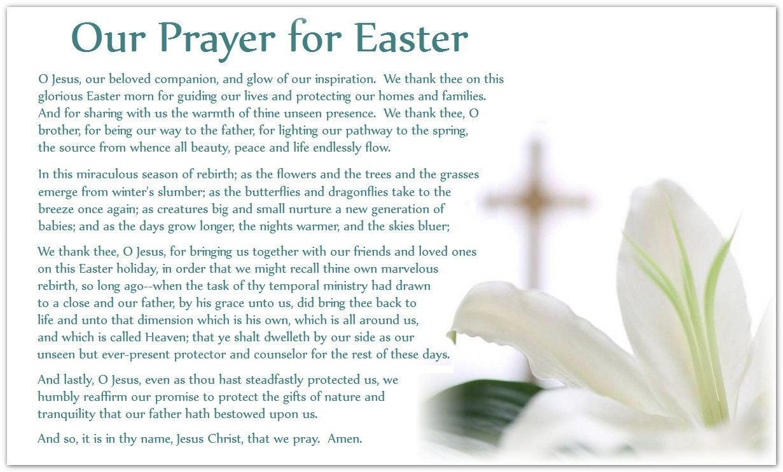

Meeting Minutes / Reports
Page 6 of 13

St. Johns United Church of Christ
Council Meeting
February 11, 2019

Present: Kurt Schultz, Dorothy Schultz, Miriam Guyor, Rev. Ken Gadd, Carolyn Hosford, Georgia Phelan, Loretta Prange, Lynn Andrews
Absent: Lynn Reh, Denise Beattie

Call to order at 6:45 p.m. Opening prayer by Ken Gadd.

- Minutes of the January 14, 2019 meeting presented by Miriam. Motion by Dorothy to accept minutes as presented. Second by Georgia. Carried.
- Reports
- Treasurer’s Report presented by Dorothy. Motion by Georgia to accept report as presented. Second by Carolyn. Carried.
- Financial Secretary’s Report presented by Loretta. Motion by Georgia to accept report as presented. Second by Miriam. Carried.
- Mary Martha Guild
- Dave Endres of Endres Interiors came in to measure for window treatments (honeycomb blinds.) We will get at least one more quote. There is $639 in the window fund at this point. Fun and Games night is partially supporting this fund.
- Feb. 14 is luncheon and meeting. Feb. 16 will be Fun and Games Night.
- Sunday School. No report at this time.
- Pastor’s Report
- Ash Wednesday service will be held March 6 at 7 p.m. at St. James. Discussion groups will be held the following Wednesdays of Lent (March 13 – April 3.) April 10 will be the Seder meal at St. John’s. Good Friday services will be 12:30 p.m. at St. James and 7 p.m. at St. John’s. Great Easter Vigil will be at St. James on April 20 at 7 p.m.
- Rev. Gadd is scheduling a baptism for a potential new member of our congregation.
- We will publish in the bulletin that those guests interested in membership can contact Rev. Gadd by phone, email or a note to him.
- Building and Grounds
- Kurt is looking for a contractor available to address our boiler issue.
- Our pianist has told Kurt the lighting for the piano is sufficient. The baby grand piano has been moved to a new home with a Marine City family.
- Kurt found a water leak in the line going to the sacristy. The water has been shut off to that area and Kurt will get it fixed.
- All exterior lighting is working except the sign. We will look into installing LED lighting in it in the spring.
Page 7 of 13
- Unfinished Business
- Pastor’s Contract. Ken will get a signed copy in to us.
- Cleaning person. Georgia has found an interested person. We will schedule a meeting with her and consider a probationary period of employment to determine if she will work out.
- New Business
Nomination and election of officers. Positions to be filled are President and Secretary.
Georgia nominated Lynn Andrews for Secretary. Second by Dorothy and accepted by Lynn.
Miriam nominated Georgia Phelan for President. Second by Carolyn and accepted by Georgia.
Both nominations were voted on and carried.

Carolyn made the motion to adjourn at 8:20 p.m. Second by Dorothy and carried.
Closing prayer by Dorothy.

Submitted by Miriam Guyor
Secretary

Page 8 of 13
Treasurer’s Report

February Treasurer’s Report

Beginning Cash $84,684.94
Receipts. 3,320.65
Expenses 4,557.92
Ending Cash $83,447.67

Cash on Hand
Savings Account $41,170.61
Flagstar Savings 33,762.67
Checking Account 8,514.39
Total $83,447.67

Cert. of Deposit $ 8,781.87
Fah Savings 2,370.10
Total $11,151.97

Grand Total on Hand. $94,599.64

Submitted by,
Dorothy Schultz, Treasurer

Page 9 of 13
Mary Martha Minutes

Mary Martha Minutes from the meeting held on February 14, 2019

The meeting was called to order at 1:00 pm by Loretta.

Members present: Linda, Carolyn, Loretta, Lois and Lynn.

Minutes from the November 2018 meeting were read by Lynn. Motion by Linda, seconded by Lois to
accept the minutes as presented. Motion carried.

Minutes from the January 10 meeting were read by Lynn. Motion by Linda, seconded by Carolyn to
accept the minutes as presented. Motion carried.

Treasurer’s report was presented by Lynn. Current balance in the checking account is $171.87. Motion
by Carolyn, seconded by Lois to accept the Treasurer’s report. Motion carried. Lynn and Lois paid their dues for the year.

Old Business - There are approximately 20 cookbooks left. We will try to sell them at the Rummage Sale. Lynn will begin updating the Memorial Book. This may take some time to organize and complete.
We will be getting estimates from Endres Interiors and JC Penney for the window treatments. We tabled discussion about changing our meeting date to another day.

New Business - Carolyn made a motion, seconded by Linda, that we place a container on the counter for coffee donations. Motion carried. Loretta and Lynn will present to Council before we begin this. We discussed having a Soup and Bread meal prior to the weekly Lenten studies. Loretta and Lynn will go to Council with this before a decision is made. Lois will talk to Pat Kaufman about making an afghan to raffle off at the Rummage Sale.

Motion made by Linda, seconded by Lynn to adjourn the meeting at 2:20pm. Motion carried.

Respectfully submitted,
Lynn Reh
Secretary/Treasurer

April Events and Activities
Page 10 of 13
Monday, April 1 - 2:30 pm - God’s Grace Through Prayer meets in the Fellowship Room. Everyone is welcome to join us.

Wednesday, April 3 - 7pm - Lenten Studies at St, John’s

Sunday, April 7 -11am - Morning Worship with Holy Communion and Sunday School, Coffee Hour following Worship.

Monday, April 8 - 2:30pm - God’s Grace Through Prayer meets in the Fellowship Room.
6:30pm - Council meets in the Fellowship Room.

Wednesday, April 10 - 12:30pm - Mary Martha Guild meets for lunch and meeting.
Bring a sandwich. Dessert and Beverage will be provided. Bea Gubanche is hostess. All women of the church are welcome to join us.
7pm - Seder meal at St, John’s.

Saturday, April 13 - 6-9pm - Fun and Games Night in the Fellowship Room. Cost is $5 per person/$8 per family.

Sunday, April 14 - 11am - Palm Sunday Morning Worship and Sunday School.

Monday, April 15 - 2:30pm - God’s Grace Through Prayer meets in the Fellowship Room.

Friday, April 19 - 12:30pm - Good Friday. Service at St. James at 12:30pm.
Service at St. John’s at 7pm.
Saturday, April 20 - 7pm. - Great Easter Vigil at St. James at 7pm.

Sunday, April 21 - 11am - Resurrection Sunday Morning Worship with Holy Communion and Sunday School.

Monday, April 22 - 2:30pm - God’s Grace Through Prayer meets in the Fellowship Room.

Sunday, April 28 - 11am - Morning Worship and Sunday School

Monday, April 29 - 2:30pm - God’s Grace Through Prayer meets in the Fellowship Room
.
Page 11 of 13
Mad Hatter Tea Party
Saturday, April 13, 2019
Follow the White Rabbit to…..
St. James Church Basement
2:30pm -5:30pm
We will have an afternoon of Fellowship, Fun and Food

Coffee, Variety of Teas, Punch and Cake will be provided

Sign-up is in the church basement let us know how many and what dish you’re bringing to pass.
Menu of…..
(Soup, salad, Sandwiches, scones, fruit, or cheese and crackers)
A donation of $5.00 is requested and will be donated to a Blue Water Safe Horizons.
Don’t be late for this very important date!

Sign-up sheet in in the Fellowship room.

Additional Activities
Page 12 of 13
Pantry Box

God’s Grace Through Prayer, our St. John’s Prayer Group, is sponsoring a Pantry Box. The box is in the Fellowship Room. We are accepting any non-perishable items. These will be donated to the Downriver Helping Hands and other organizations in the area. Please help support those in need in our Community. Thank you!
Special Dreams Farm
We will be doing community service with Special Dreams Farm. Special Dreams Farm, located at 6524 Fred Moore Hwy., St. Clair Township, MI 48079 is a real working farm for adults with developmental disabilities. We will be collecting paper products, such as paper towels, napkins, paper plates, toilet paper, Kleenex tissues, plastic silverware to be delivered to the farm. Look for the box in the Fellowship Room marked for Special Dreams Farm Donations. We will be accepting cash donations, as well.

The Farm has a store which is open to the public to purchase home grown products (flowers, fruits, vegetables, eggs) and crafts made by the farm workers. If you’re in the area, stop by and visit. You’ll be surprised at what’s happening at Special Dreams Farm.

Annual Rummage Sale

It’s that time of year again for the Annual Rummage Sale. The following is the schedule for this year’s sale:
Monday and Tuesday, April 29 and 30 - Set up for the Sale beginning at 9am.
Wednesday, May 1 - Baking Day.
Thursday and Friday, May 2 and 3 - Rummage Sale from 9am to 3pm.
Saturday, May 4 - Rummage Sale from 9am to Noon. Fill a Bag for $3.00.
If you have any items to bring in for the Sale, you may begin doing so anytime from now until the Sale. Donations can be placed in the corner of the Fellowship Room.

Page 13 of 13

Scripture Reading for April 2019

Sunday, April 7 Sunday, April 14
Fifth Sunday of Lent Sixth Sunday of Lent-Palm Sunday
Isa 43: 16-21 Ps 118: 1-2, 19-29
Ps 126 Luke 19: 28-40
Phil: 3: 4b-14 Isa 50: 4-9a
John: 12: 1-8 Ps 31: 9-16
Something New Phil 2: 5-11 Luke 22: 14-23:56 or Luke 23:1-49 Into Jerusalem

Sunday, April 21 Sunday, April 28
Easter Second Sunday of Easter
Acts10: 34-43 or Isa 65: 17-25 Acts 5: 27-32
Ps 118: 1-2,14-24 Ps 118: 14-29 or Ps 150
1 Cor 15: 19-26 or Acts 10: 34-43 Rev 1: 4-8
John 20: 1-18 or Luke 24: 1-12 John 20: 19-31
Resurrection Joy Resurrection Witness

St. Johns United Church of Christ
527 N. William Street
Marine City, MI 48039
Phone:
(586) 727--1623
Fax:
(586) 27-0833
E-mail:
kgadd@stjohnsmarinecity.org
We’re on the Web!
stjohnsmarinecity.org

April
NEWSLETTER

