St. Johns United Church of Christ
527 N. William Street, Marine City, MI 48039

Greetings to all

For many years now, November has been a spiritually significant month for me. There are many events and church remembrances that fill me with a sense of gratitude and an appreciation for God’s grace in my life. I have often said, “I have not gotten all that I deserve…. And for that I am grateful”.

The month always begins with All Saints Day, a day that allows me to remember and honor all those on whose shoulders I stand, both past and present. There have been so many people that have touched my life in so many wonderful ways. I truly enjoy thinking about them while on my journey, knowing they travel with me fills me with grace and humility.

About grace, this is the month that causes me to be intentionally focused on gratitude. As always, I quote my old friend Dwight who used to regularly remind me that “gratitude is the aristocrat of attitudes”. I could not agree more. Gratitude for me is where joy and contentment are found. He would also regularly remind me that I could not get what I wanted until I wanted what I got. I don’t necessary think that was about wanting lives hardships or the possibility of the future accumulation of “stuff” so much as a reminder that happiness and contentment are found inside rather than outside of us. And once we wanted what we had (gratitude) we would not find it so necessary to have the “stuff”.

And then there is Thanksgiving. Thanksgiving is one of my favorite holidays. Perhaps it is because the marketing world and big box stores have not figured out how to make a ton of money on it yet. Even though it makes me crazy that some stores want to be open Thanksgiving night to take peoples Christmas money I am even happier that some stores who tried it the last couple years have decided to stay closed this year.

In these challenging times, it can seem difficult at times to find things to be grateful for.

Contents
News from Pastor Ken 1
Pastor Ken News Cont. 2
Birthdays 3
Worship Ministry 3
Military Prayer List 3
Prayers Needed 3
Kid’s Page 4
Thanksgiving Poem 5
November Activities 6
Additional Activities 7
Fun and Games Night 7
Recycle 7
Minutes/Reports 8 - 10
Scripture Readings 10

https://www.facebook.com/Stjohnsuccmarinecity/

News from Pastor Ken

The purpose of a newsletter is to provide specialized information to a targeted audience. A school newsletter can be a great way to develop a strong relationship with parents.
First choose a short title for your newsletter— something like "School News," or “Back to School.” As you choose the title, also take time to think about the newsletter’s theme. What important messages do you want to send parents and families?
Next, establish how much time and money you can spend on your newsletter. These factors will help determine how frequently you publish the newsletter and its length.
Use the body of your school newsletter to keep parents apprised of major assignments and class events, as well as any of school district news. Also share news for specific grade levels, and tell parents about upcoming events, new faculty, and school policies.

Dear Parents

Page 2 of 10
Pastor Ken Newsletter Continued

Therefore, here is my annual invitation for you to participate in one of my more meaningful Thanksgiving practices. Every year, sometime around Thanksgiving I write a list of 4-6 things that I am TRULY grateful for (I’m not talking about grateful for chocolate ice cream grateful, though I am, but what I am TRULY grateful for). As a side note, if you can only think of one or two- think harder, if you want to write 20-30, then think harder and prioritize the top 4-6. Then I put the list somewhere I can see it regularly, on the refrigerator, near the computer monitor, bathroom mirror, you get the idea, as a reminder. Sometimes when life gets challenging, it can be easy to forget. It is helpful for me to have a little written reminder of God’s many blessings in my life.

If you are one who finds themselves bubbling over with gratitude, or at least have some sense of it. I encourage you to lend a hand, write a note, make a call or drop an email to someone who you know who could use a little reminder (by the way, that’s just about everybody) that one of lives blessings is that we have people in our life that simply care. Sometimes it is the smallest gestures that make the biggest difference.

I am also looking forward to my Advent time of reflection and preparation. It begins the first Sunday in December this year. I invite you to participate with me in some small way. It is about a daily reminder of my relationship with God. Truly a time of prayer and meditation. I invite you to join me in remembering that despite what the major retailers would have us believe, Advent is not Christmas. It is a time of intentional and internal preparation for the spiritual gifts of Christmas. More on this next month.

You have touched my life in significant ways and I give thanks daily for you. I wish you a Thanksgiving Season filled with grace and gratitude that lasts throughout the year. Remember that whoever you are and wherever you are on life’s journey, you are held in God’s unconditional love, boundless mercy, unending grace and that there is a place for you here.
Take care and be well, Peace
Ken

And I thought you might find this interesting…. Definitions of Gratitude

Webster: Synonyms and Antonyms of GRATITUDE
acknowledgment of having received something good from another <accept these flowers as a token of my gratitude>
Synonyms appreciation, appreciativeness, gratefulness, gratitude, thankfulness
Related Words: thanksgiving; gratification, indebtedness, satisfaction; acknowledgment (oracknowledgement), recognition,
tribute

Christian Bible: Thankfulness, Thanksgiving

Gratitude in Islam
Gratitude in Islam is one of the most fundamental aspects of this religion. A Muslim is not merely one cognizant of the fact that the creator of the universe is one and is responsible for everything he has in this life i.e. his consciousness, his health, his family, his sanity and his wealth but also realizes that it is his obligation to express gratitude to his lord.

Gratitude in Judaism
The Hebrew term for gratitude literally means “recognizing the good”. Practicing gratitude recognizes the good that is already yours.
Anniversaries in November

Happy Birthdays in November
Page 3 of 10
11/11 Bob & Sandi Fritz
11/21 Nelson & Loretta Prange
11/1 Betty Reynolds
11/3 Kathy Gallagher
11/3 Dorothy Schultz
11/4 Mark Hincherick
11/6 Sandi Fritz
11/20 Patrick Phelan
11/22 Lisa Forest
11/24 Bill Galvin
11/26 Matthew Hincherick
11/28 Judy Lester

Worship Ministry

Volunteers Needed
Please sign-up

Please consider signing up for the ministries of Usher/Greeter, Liturgists and Altar Care.

Prayers For ……

Ryan Reuben
Mary Ann Tamara
Doris Reggie
Harvey Charley
Lauren Gary
Wayne Ida
Jim Alma
Rosemary Tricia
Nicolette Daniele
John Pennie
Michelle Tom
Beth Michele
Julia Victor
Bill Steve
Jim Gordy
Jay Marion
Rick Barb
Claudette Renee
Janet Mike
Pat Mary
Stacy Carolyn
Judy David
Robert
Family of St. Johns and
St. James

Military Prayer List
I will be including a list in the newsletter of our men and women in the military, to acknowledge those who serve and to pray for their safety. Please submit your love one’s, family member or friend’s name, rank and branch of service to be placed
on the list.

Josh Bieske Staff Sgt. US Air Force

Page 4 of 10
Kid’s Page

Color picture per instructions below.
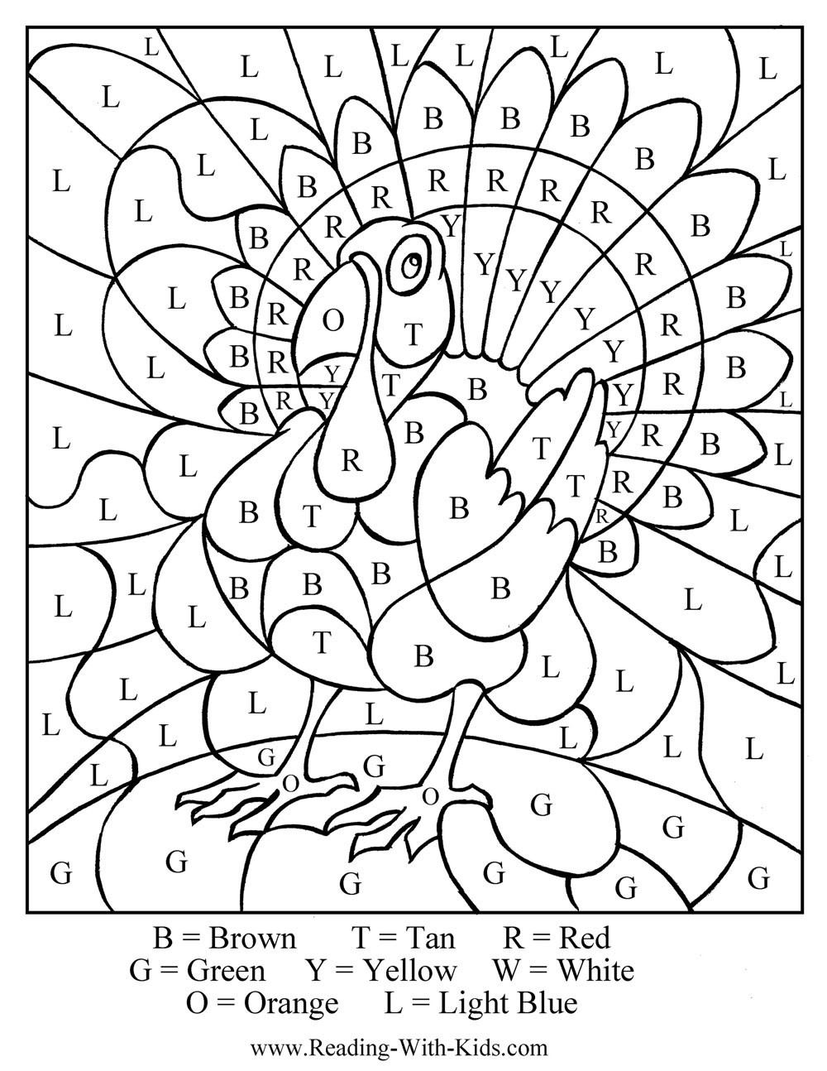
Thanksgiving Poem
Page 5 of 10

November Activities
Page 6 of 10

Sunday, November 4 - 11 am - Morning Worship with Holy Communion and Sunday School Coffee Hour following worship.
Monday, November 5 - 2:30pm - God’s Grace Through Prayer meets in the Fellowship Room.
Thursday, November 8 - 12:30pm - Mary Martha Guild meets for lunch followed by our business meeting. Bring a sandwich. Dessert and beverages are provided. Our hostess is Loretta Prange.

Saturday, November 10 6-9pm Fun and Games Night. Fellowship Room.

Sunday, November 11 - 11am - Morning Worship and Sunday School.
Monday, November 12 - 2:30pm - God’s Grace Through Prayer meets in the Fellowship Room.
6:30pm - Council meets.
Sunday, November 18 - 11am - Morning Worship with Holy Communion and Sunday School.
12pm - Brunch at Riveria in Marine City
Monday, November 19 - 2:30am - God’s Grace Through Prayer meets in the Fellowship Room.

Thursday, November 22 - Thanksgiving Day. Take time to be thankful for the many gifts that God has given us.

Sunday, November 25 - 11am - Morning Worship and Sunday School.

Monday, November 26 - 2:30pm - God’s Grace Through Prayer meets in the Fellowship Room.

Additional Activities
Page 7 of 10
Pantry Box

God’s Grace Through Prayer, our St. John’s Prayer Group, is sponsoring a Pantry Box. The box is in the Fellowship Room. We are accepting any non-perishable items. These will be donated to the Downriver Helping Hands and other organizations in the area. Please help support those in need in our Community. Thank you!
Special Dreams Farm
We will be doing community service with Special Dreams Farm. Special Dreams Farm, located at 6524 Fred Moore Hwy., St. Clair Township, MI 48079 is a real working farm for adults with developmental disabilities. We will be collecting paper products, such as paper towels, napkins, paper plates, toilet paper, Kleenex tissues, plastic silverware to be delivered to the farm. Look for the box in the Fellowship Room marked for Special Dreams Farm Donations. We will be accepting cash donations, as well.

The Farm has a store which is open to the public to purchase home grown products (flowers, fruits, vegetables, eggs) and crafts made by the farm workers. If you’re in the area, stop by and visit. You’ll be surprised at what’s happening at Special Dreams Farm.

Fun and Games Night

The Mary Martha Guild is sponsoring a Fun and Games Night on Saturday, November 10 from 6-9 pm in the Fellowship Room at St. John’s. Everyone, young and old, is invited. Bring along your favorite game or we’ll have some here for you…Euchre, Yahtzee, Bunco, Trivial Pursuit, just to name a few. Snacks and beverages are provided. The cost is $5 per person or $8 per couple or family. Sign-up sheets are on the counter in the Fellowship Room. See you there!!

Page 8 of 10

Meeting Minutes/Reports
St. John’s United Church of Christ
Council Meeting
September 10, 2018

Present: Kurt Schultz, Dorothy Schultz, Lynn Andrews, Lynn Reh, Loretta Prange, Georgia Phelan, Miriam Guyor, Rev. Ken Gadd
Absent: Carolyn Hosford, Denise Beattie

Meeting called to order at 6:40 p.m.

- Minutes of June 11, 2018 meeting presented by Miriam. Motion to accept as presented by Lynn R, second by Dorothy. Carried
- Reports
- Treasurer’s Reports for the months of July and August presented by Dorothy. Motion by Georgia to accept as presented, second by Miriam. Carried.
- Financial Secretary’s Reports for the months of July and August presented by Loretta. Motion by Georgia to accept as presented, second by Lynn R. Carried.
- Mary Martha Guild. Next meeting to be held this Thursday, no report as this time.
- Sunday School.
!. Classes will begin the first Sunday in October.
2. Lynn Reh found a new curriculum from Cokesbury that can be used for all ages to allow us to combine the two classes. It has been ordered.
3. Rev. Gadd has asked that the children attend the beginning of the service, then go to their class.
4. The same teachers will be returning with Lynn Reh taking Tamara’s place.
E. Pastor’s Report
1. Ken would like to create a Health and Vitality Team to review where we’ve been, where we’re at and where we want to go and determine what our vision is for the future. He will ask the congregation for participants.
2. Ken would like to be informed of member illnesses, shut-ins, etc. so he can contact them regarding visitation and/or support. He would also like to be made aware of any extra meetings that take place.
3. Ken inquired about his contract renewal. This is being addressed.
III. Unfinished Business
- Building and Grounds
- Three contractor quotes were received for exterior work that needs to be done. R.V. Construction was not acceptable. Georgia contacted Corber Construction and Netherland Construction to compare their quotes and specific work to be done. Corber quoted a cost of $18,950, Netherland quoted $14,360. Motion by Lynn Reh that we recommend to the congregation that Netherland Construction do the required exterior work at a cost of $14,360. Second by Loretta. Carried. The congregational meeting to approve will be announced on Sept. 16 and 23 and held on Sept. 30.
Page 9 of 10
- Ken has someone who can install the new lights in the Sanctuary. He can probably install the new smoke detectors as well.
- Mike and Georgia Phelan looked over the condition of the gazebo. There is some rot in the steps and bee damage in areas of the wood. The roof looks good. It needs to be stained/weather-proofed. We will check with Netherlands Construction on a cost to do these repairs.
IV New Business
Don Weichert asked to be replaced for scheduling the Fellowship Hall usage. Miriam will take his place.

Dorothy made the motion to adjourn at 7:50 p.m., second by Loretta. Carried.

Submitted by Miriam Guyor
Secretary

Let’s Recycle

Watch for the new blue recycling bins at St. John’s! We will be recycling paper (weekly service programs included) and other paper. Look for that bin near the doors to the Sanctuary. We’ll also be recycling plastic, like water bottles and plastic cups. That bin will be near the coffee station. Let’s tread lightly on God’s earth- help us go green at St. John’s and recycle your paper and plastic!

Meeting Minutes / Reports
Page 10 of 10

Treasurer’s Report

Treasurer’s Report as of September, 2018

Beginning Cash - $ 98,059.17
Receipts - 7,899.05
Expenses - 4,221.52
Ending Cash $101,736.70

Cash on Hand
Savings Account - $ 57,449.66
Savings Account Flagstar - 33,748.43
Checking Account. - 10,588.61
Total - $101,736.70

CD Account - $ 8,770.94
Fah’s Savings 2,369.61
$ 11,140.55

Total Cash on Hand. - $ 112,877.25

Respectfully Submitted,
Dorothy Schultz
Treasurer
Scripture Reading for November 2018

Sunday, November 4 Sunday, November 11
Thirty-first Sunday in Ordinary Time Thirty-second Sunday in Ordinary Time
Ruth 1: 1-8 Ruth 3: 1-5; 4: 13-17
Ps 146 or Deut 6: 1-9 Ps 127 or1 Kings 17: 8-16
Ps 119: 1-8 Ps 146
Heb 9: 11-14 Heb 9:24-28
Mk 12: 28-34 Mk 12: 38-44
Wherever You go Risk & Restoration

Sunday, November 18 Sunday, November 25
Thirty-third Sunday in Ordinary Time Reign of Christ
1 Sam 1: 4-20 2 Sam 23: 1-7
1 Sam 2: 1-10 or Daniel 12: 1-3 Ps 132: 1-12, (13-18) or Daniel 7: 9-10,
Heb 10: 11-14, (15-18), 19-25 13-14
Mk 13: 1-8 Ps 93
Praise the Holy One Rev 1: 4b-8
Jn 18: 33-37
A Wise Reign

St. Johns United Church of Christ
527 N. William Street
Marine City, MI 48039
Phone:
(586) 727--1623
Fax:
(586) 27-0833
E-mail:
kgadd@stjohnsmarinecity.org
We’re on the Web!
stjohnsmarinecity.org

November
NEWSLETTER

